

**1214   
Currants**

Currants generally are low-growing deciduous shrubs that reach three to six feet in height and have thorny or thornless stems. Currants can be grown in home gardens and landscapes. They're also grown commercially and their fruit is fresh-frozen or used in jams and pies. Currants contain several minerals and are high in vitamins A, B and C.[[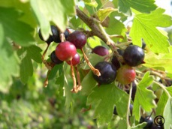](http://www.ext.colostate.edu/ptlk/1214f1a.html)](http://www.ext.colostate.edu/ptlk/1214f1a.html)

Red currants are tart and often are used in jellies. White currants are sweeter and can be consumed fresh. Black currants are used to produce Creme de Cassis, a liqueur, as well as jellies and pastries.

Currants do best in cool soil temperatures with full sun. They're winter hardy, growing in USDA Hardiness zones three to five. Native species are found in northern parts of North America, and will even grow at elevations up to 10,000 feet. Consequently, they perform better in some shade, as they may defoliate if temperatures exceed 86 degrees Fahrenheit for an extended period. It's best to plant them on north-facing slopes, and use mulch to moderate soil-temperature fluctuations.

Currants do best in fertile, loamy soil that has good drainage. Optimum pH is 6.2 to 6.5, but they tolerate 5.5 to 7.0. At a higher pH, the fruit quantity may be limited, but the plants can still be used for landscaping.[[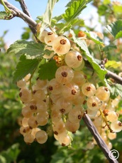](http://www.ext.colostate.edu/ptlk/1214f2a.html)](http://www.ext.colostate.edu/ptlk/1214f2a.html)

Currants are an alternate host for white pine blister rust, so avoid planting them with white pines. Fortunately, white pine blister rust generally isn't a problem in the Rocky Mountain and High Plains regions.