

**1912   
Xeriscape turf & alternatives**

Is Colorado a desert? Not quite, but almost. Moist areas along the Front Range receive about 15 inches of precipitation a year. And Kentucky bluegrass, the type of lawn most commonly grown here, grows best on 30 or more inches of moisture a year. That means you'll need to apply an additional 15 inches of water a year to successfully grow your bluegrass lawn. Such use places a high demand on water -a limited resource vital to Colorado.

[[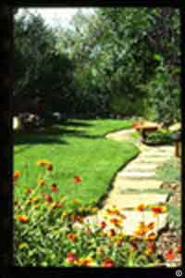](http://www.ext.colostate.edu/ptlk/1912a.html)](http://www.ext.colostate.edu/ptlk/1912a.html)

Lawns offer many benefits, and it makes sense to plant grass where it's appropriate. Lawns anchor soil against wind and water erosion, and provide a safe surface on which children and adults can play and hold sporting events. Lawns also offer landscape variety when mixed with trees, shrubs and other plants.

However, in some situations, lawns simply aren't practical. Lawns located on steep slopes or narrow strips, in the shade, and in areas that receive heavy foot traffic are poor choices. Instead, consider terraced flower beds on slopes, ground-cover plants in narrow strips, perennials or shrubs for shady areas, and a patio, flagstone path or sidewalk for heavily traveled areas.

Where lawns are appropriate, consider a substitute grass that grows well with less water. Water-thrifty buffalo grass works well in out-of-the-way expanses of a property. Dark green turf-type tall fescue grows deep roots and requires less irrigation when planted on well-prepared soils. Tall fescue also tolerates wear and tear from children playing. In the right location, buffalo grass and turf-type tall fescue will beautify any landscape.

Planting a yard means more than painting a carpet of green grass from property line to property line. Consider the impact your plant choices have on water supplies and the state's environment. Choose the appropriate turf and turf alternatives.