

NURSERY, GARDEN CENTER, GREENHOUSE & PATIO
5150 Garrison St. Arvada, CO 80002 303-424-7979
www.echters.com

AFRICAN VIOLET
Saintpaulia ionantha
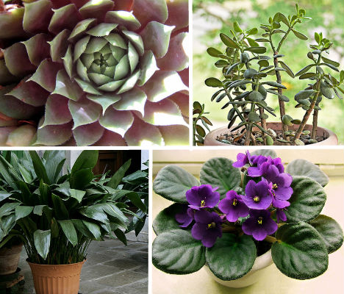
Since their discovery in Tanganyika (now Tanzania) in 1892, African violets have become a favorite in many homes. Whether grown near a window or under fluorescent light, African violets hybrids are extremely rewarding. They flower freely year round and tolerate home conditions.

TEMPERATURES: Average warmth needed during the day 70-80 degrees, night time temperatures should average 60-70 degrees. Avoid cold drafts and sudden changes in temperature.

LIGHT: Bright light is recommended, ideally an east or south window in winter. Always protect from strong sunlight. For winter blooming provide some artificial light at night. To grow entirely by artificial light use two 40W fluorescent tubes about 12” above the plants for 15-18 hours each day.

WATERING/FERTILIZATION: Water plants from the top or below, with room temperature water or slightly warmer, but avoid watering crown or leaves. Wick-irrigated pots work well. Also wet soil thoroughly, then let potting mixture become dry to the touch before watering again. Empty water in pot saucers 1/2 - 1 hour after watering. If plant is well established, feed only when soil is moist with slightly acid (12-36-14) type fertilizer once every 2-4 weeks.

REPOTTING: Violets won’t take just any potting soil mix. Violets require a highly organic, well draining medium. Repot, if necessary, in spring into next size pot. African violets bloom better when roots are crowded.

PROPAGATION: Leaf cuttings into soil, divisions or sow seeds in spring.

AIR HUMIDITY: Preferably, humidity around plants by setting plants on pebble tray.

SPECIAL HINTS: Remove faded flowers and damaged leaves.

