
NURSERY, GARDEN CENTER, GREENHOUSE & PATIO
5150 Garrison St. Arvada, CO 80002 303-424-7979
www.echters.com

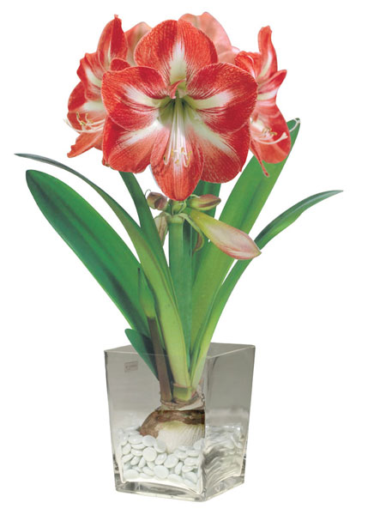
Amaryllis Care Sheet

Amaryllis, plants of regal bearing and exotic flower are unsurpassed as window gardening material. Within the layers of each brown bulb is locked the key to real garden magic. The unusual beauty and ease of culture of the new hybrids has greatly increased the popularity of amaryllis. A good amaryllis bulb will reward you with huge bouquets of sparkling fresh flowers borne on sturdy flower stems. The distinguishing marks of these choice Dutch hybrid amaryllis; timely textured over lapping petals and an abundance of flaring "pansy-faced" flowers are characteristic of our amaryllis bulbs.

Individual flowers, in a wide array of pure or blended colors, measure up to 8 and even 10-inches across the face. And it is not unusual for a single bulb to produce 4 to 8 of these big beauties in colors to please even the most discriminating of gardeners. Glistening white, salmon, rose, light, bright or dark red, rich golden-flecked orange, color contrasts or blends, brilliant or subdued stripes on a white background will lend a splash of just-right color to any indoor garden.
Potting

Center the bulb in the pot and if about an inch of free space remains between it and the pot, your amaryllis will have plenty of growing space. A 6 or 8 inch pot is about right for most bulbs. Place an inch of pot chips or pebbles for drainage in the bottom of the pot. There are several kinds of commercial packaged soil mixtures on the market, but if you like to prepare your own you'll find this a good one: equal parts of good garden soil, leaf mould and sand. Plant the bulb so that one-half to two thirds of it is above the soil line.

Watering
After potting, water the soil thoroughly with warm water. If you want to bring on an early flower crop, place the potted bulb in a warm 70-75 degrees F. room, delay flowering by setting in a cool dark room. Bulb in warm room needs to be watered at least once a week; in cooler spots they will not need such frequent watering.
As soon as leaves of flower buds show, place the amaryllis in an east, southeast or south window or fluorescent lighted spot. Water either from top or bottom, but do a thorough job. Then don't water again until the topsoil feels dry to touch. Within about 60 days you will have a floral crop that will be the envy of all your gardening friends. After the buds unfold, flowers will last longer if you move the plant out of the direct sun.

Fertilizing
To help form next year's flower buds start fertilizing your amaryllis as soon as the flowers fade. Amaryllis are huge "eaters" and must grow a number of long strap-like leaves to help them store food and flowers. Use any good all purpose fertilizer or, if you prefer an organic type, try fish emulsion. Fertilize amaryllis twice a month. Never apply fertilizer to dry soil, always water the plant before application. Fertilizer of any kind, applied to dry soil can burn tender roots and retard plant growth.

Summering
If you own a garden, summer your amaryllis by sinking the pot in the soil or by removing the bulbs from the pot and planting directly into the soil. Continue the fertilizing program. Grown outdoors, they prefer a location where they receive filtered sun.

Storage
In early to mid-September outer leaves often begin yellowing, an indication the amaryllis needs a rest. Cut all leaves to within an inch of the neck of the bulb. Repot garden planted ones; scrape away old topsoil on the potted ones and replace with about an inch of fresh soil. Store amaryllis in a cool spot, 50 to 55 degrees F. Moisten them slightly about once a month to keep them from shriveling. In late December or early January when they show signs of growth, water them and bring into warmth and light. Here they will bring to your winter window garden another mass of gorgeous color.

