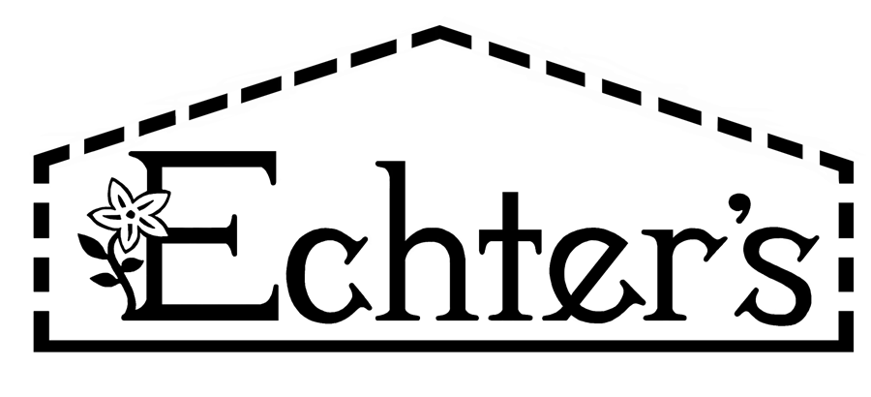

NURSERY, GARDEN CENTER, GREENHOUSE & PATIO
5150 Garrison St. Arvada, CO 80002 303-424-7979
www.echters.com

Annual

Ryegrass VNS

Sow Rate: 8 pounds per 1,000 square feet

Green-Mature crop: 10 pounds per 1,000 square feet

In the northern latitudes Annual Ryegrass is used as a nursery grass in mixtures to provide protection for species that are slow to establish such as Buffalograss. In the southern latitudes it is used to winter over-seed, warm-season grasses such as Zoysia and Bermuda grass.

In the northern states it is not a hardy grass and will not over-winter in the cold climate. The few plants that might over-winter take on a stemmy-weed-like appearance the second year.

New home contractors often use annual ryegrass in the spring to give the appearance of installations of complete lawn. If you find this has been done to your new home, simply cultivate the annual ryegrass into the soil, using it as a green-manure crop, and reseed the lawn in the late summer months. Make sure you recheck your builder’s contract that you have not been charged for a new lawn!

Very quick to germinate and establish within only several weeks. Excellent when used as a cover-crop in organic-gardening techniques to enrich the soil. May also be used as a quick cover for fire burned areas to temporarily hold the soil in place until a permanent (perennial) species germinates and covers the fire burned area.

