

NURSERY, GARDEN CENTER, GREENHOUSE & PATIO
5150 Garrison St. Arvada, CO 80002 303-424-7979
www.echters.com

AZALEA CARE SHEET

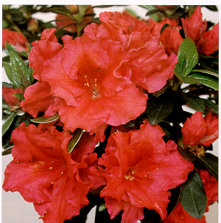
One of the most popular flowering plants is Rhododendron simsii or Indian Azalea. It is a dwarf shrub reaching a height near 1 1/2 feet. When properly cared for blooms may last up to 6 weeks.

Azaleas need bright indirect light. Keep them out of direct sun. The plant needs to be kept cool. Ideal temperatures are 50 - 60 degrees Fahrenheit. Keep the potting mix evenly moist. Do not let the pot stand in water. Never let the potting mix dry. When repotting, choose a light, fast draining mix. Fertilize with acid fertilizer when not in bloom. While in bloom fertilize with all purpose fertilizer. Choose a plant with lots of buds for longer lasting show.

Flowers wilting prematurely and leaf loss or shriveled leaves are indications of under watering. Increase the watering frequency and be sure that potting mix is saturated should you see any of these indicators.

