

NURSERY, GARDEN CENTER, GREENHOUSE & PATIO
5150 Garrison St. Arvada, CO 80002 303-424-7979
www.echters.com

Bearded Iris
Iris germanica
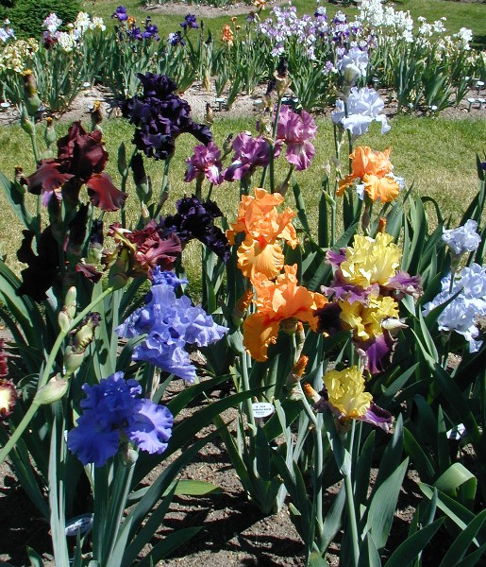
General:
Bearded Iris are one of the easiest perennials to grow. They will survive with little care and reward you with blooms in late spring to early summer. Their large, lush flowers are often compared with orchids for exotic appeal. Following a spring show of flowers, Iris foliage provides good vertical accent in the garden. The sword-like leaves contrast well with fine-textured perennials. Painted Daisy, Blue Flax and Coreopsis ‘Moonbeam’ are great companions.

Culture:
Iris will thrive in full sun and prefer well-drained soils. Heavy clay soils should be enhanced by the addition of sphagnum peat moss and compost to improve drainage. Iris are water-smart perennials and need only occasional irrigation during the summer months. A high phosphorous – low nitrogen fertilizer (Colorado’s Own 5-10-5 or Fertilome Gardener’s Special 11-15-11) may be used in the spring on established plants.

Planting:
Container grown Iris may be planted at any time during the growing season. Take care to plant so the top of the iris rhizome is slightly exposed. Super phosphate may be added to the soil at planting time.

Dividing:
Late summer is an excellent time to rejuvenate over-crowded Iris. Clumps usually require division every 3-4 years to maintain flowering vigor and strength. Dig clumps and separate into individual rhizomes. Discard soft or dried rhizomes selecting firm rhizomes with fresh roots for replanting. There are usually extra divisions for fellow gardeners.
Replant following the previously outlined procedures. Rhizomes should face toward the outside when planting in groups to prevent the clump from overcrowding too rapidly. Divisions may take a complete growing season to establish before blooming.

Insects and Diseases:
Bearded Iris are susceptible to crown rot and iris bore. Crown rot can occur if soil is too moist, causing rhizomes to soften and shrivel. A fungicide can be applied to prevent crown rot but once the rhizome is soft, cut out infected parts and destroy them. Sterilizing the knife is recommended to prevent spreading the disease.

Iris borer is an insect which travels between the layers of the leaves and into the rhizome. Indications are trailing lines in the foliage and holes in the rhizome. Crown rot can also enter at this time. Spraying with an insecticide can control bore but if crown rot has occurred, destroy infected plants.

