
NURSERY, GARDEN CENTER, GREENHOUSE, & PATIO
5150 Garrison St. Arvada, CO 80002 303-424-7979
www.echters.com

BEGONIAS

Begonias are a gardener’s delight with a variety of colors and forms available. Classified by their root systems, the four most popular types are: (1) FIBROUS-ROOTED (wax begonias), (2) SEMI-TUBEROUS (Reiger begonias), (3) TUBEROUS-ROOTED, and (4) RHIZOMATOUS (Rex begonias).

WAX BEGONIAS, usually bought as bedding plants, are profuse bloomers with either green or bronze foliage and masses of small white, pink, red, orange, or cream colored flowers. Traditionally a shady garden plant, new varieties have been bred for sunny beds. Wax begonias are the easiest to keep in bloom indoors in a bright window.

REIGER BEGONIAS, bred as house-plants, have larger flowers than the wax begonias and can be found in vibrant colors. They will bloom for months with proper care.
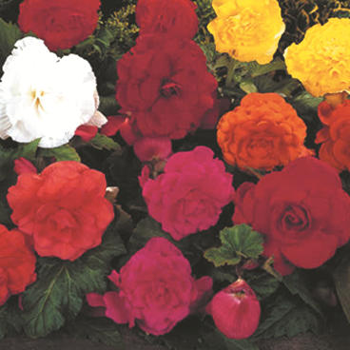
TUBEROUS BEGONIAS, are the most popular for a spectacular display of large vibrant flowers in a shady garden or as a container or hanging basket plant on your patio. Remove the small female flowers to encourage larger male blooms. Dormant tubers can be started indoors in early spring to be transplanted outdoors after the frost safe date. At the end of the flowering season withhold water, cut off the shoots, lift the tubers and store in dry vermiculite or perlite at 40-50 degrees F.

REX BEGONIAS spread by rhizomes which creep along the top of the soil. They are grown primarily as house plants for their colorful, uniquely shaped foliage.

TEMPERATURE: Average warmth, not less than 55 degrees F in winter, and try to avoid above 75 degrees F in summer.

LIGHT: Bright diffused indoors, filter sun/shade outdoors, except for plants bred to withstand more sun.

WATER: Water thoroughly when soil surface feels dry to the touch, but do not allow plants to stand in water. ** Avoid water on the foliage.

FERTILIZER: High phosphorus fertilizer for blooming varieties, general houseplant fertilizer for Rex varieties. Use with every watering.

SPECIAL PROBLEMS:

- White powdery spots – powdery mildew. Move away from other plants. Cut off diseased leaves and spray with a fungicide. Avoid over-damp conditions, low temperatures, and too low of light. Improve ventilation.
- Brown blotches, turning gray and moldy – Botrytis. Treat as above for powdery mildew.
- Yellowing Leaves – too little light, too much or too little water, not enough fertilizer.
- Leaves with brown tips – Air humidity too low, temperature too high or too much sun.
- Rotting leaves and stems – Overwatering, decrease watering and increase ventilation and lighting.
- Flower bud drop – Dry air, underwatering, low light or high temperatures may cause buds to drop.

