
NURSERY, GARDEN CENTER, GREENHOUSE & PATIO
5150 Garrison St. Arvada, Co. 303-424-7979
www.echters.com

Bromeliads
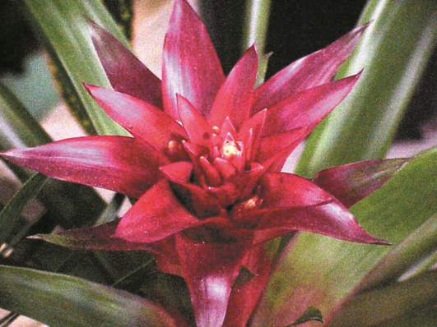
There are more than 2,000 bromeliad species. Some are grown for their flowers, others for their foliage. The most distinctive feature of the bromeliad is the cup-shaped, rosette of leaves, which holds the water that nourishes the plant.

Originating in the tropics, most bromeliads grow suspended in trees and on rocks in their native habitat. They gather moisture and nutrients from the rainfall and particles in the air.

Temperature: Average warmth (minimum 50°F)

Light: Bright light-- away from direct sunlight

Water: Guzmania (most common)- keep the central (rosette) ‘vase’ filled with water. Empty and refill the ‘vase’ every 1-2 months. Water the soil only when it dries out. Never over water, and ensure that there is good drainage. Vriesea- same as guzmania. Neoregelia- water from below the foliage to avoid rotting the flat flower in the cup of the plant.

Air Humidity: Mist leaves in summer. Feeding through the leaves is the natural method of nutrition, so occasionally spray with diluted liquid fertilizer.

Repotting: Rarely, if ever necessary.

Propagation: Offsets appear at the base of the plant. When the offset is several months old, remove it with some roots attached, and plant shallowly into a porous soil mixture. Keep warm until established. To induce a bromeliad to flower, place it in a plastic bag with a ripe apple for a few days. The ethylene gas from the apple will initiate flower buds.

