

NURSERY, GARDEN CENTER, GREENHOUSE & PATIO
5150 Garrison St. Arvada, CO 80002
www.echters.com

BUFFALOGRASS
TEXAKO KNO 3 TREATED

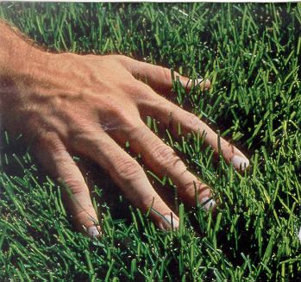
A perennial, warm-seasoned, stoloniferous prairie grass that performs best at altitudes below 7,000 feet. A protected south or west-facing exposure will allow use at higher elevations. Buffalograss is a fine-leafed, sod-forming, extremely drought-resistant turf. An excellent low-maintenance lawn when cultural requirements are met. Tolerates cold and hot weather. Adaptable to different soil types, but is particularly suited to fine-textured, neutral soils. Seeds must be covered with soil. Seeding should begin when soil temperatures are warm. Depending on soil temperatures and supplemental watering, germination should begin in 7 to 21 days.

Prefers a weekly mowing height of 2 inches. Naturally low growing to only 3 to 5 inches. Texoka will require more frequent mowing to control the weeds. Pre-emergent herbicides may be safely used on established Buffalograss in the early spring for prevention of annual weeds. 2-4D products (post-emergent herbicides) cause extreme discoloration and are not recommended.

Immune to pest and disease unless watered and fertilized abundantly. Makes excellent pasture and grazing. Very palatable and nutritious. Stands increase with grazing. Extremely difficult for livestock to “grub-out” because most of the forage is produced below 6 inches.

Cultivate and prepare soil adding peat moss and triple superphosphate prior to planting seed. Requires even, consistent moisture and warm soil to germinate. Fertilization will improve color and growth. After establishment, fertilize at 1 pound of Nitrogen per 1,000 square feet in early June and again in late July. Established lawns should be watered at very infrequent intervals but deeply, putting down several inches of water. Buffalograss has a long dormancy period from early fall to late spring.

SOW RATE: 5 POUNDS PER 1,000 SQUARE FEET

