

NURSERY, GARDEN CENTER, GREENHOUSE & PATIO
5150 Garrison St. Arvada, CO 80002 303-424-7979
www.echters.com

Harvesting & Storing Bulbs

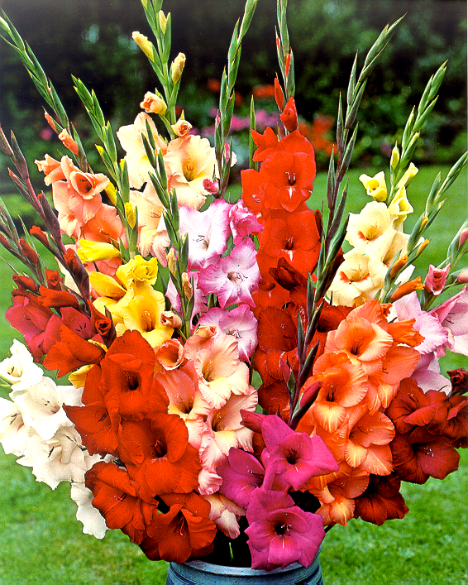
Bulbs such as dahlias, gladiolas, cannas, begonias, freesias, callas & caladiums must be dug up and stored over the winter.

After the foliage yellows in the fall dig up the bulbs with a spading fork, being careful not to bruise or nick the bulbs.

After removing the bulbs from the ground, shake off the loose soil and dry them in a shady protected spot with good air circulation for about a week. Brush off any remaining soil, and dust with a fungicide to help control any diseases.

Store the bulbs in peat moss, perlite or vermiculite in a porous bag or shallow tray. This keeps them from drying out, yet allows them to breathe. Place them in a cool (35-50 degrees) and dry place where they will not freeze such as a crawl space or garage.

Check frequently during the winter to be sure the medium is not dry. You may have to put a few drops of water in the medium to keep the bulbs from drying out.
