

NURSERY, GARDEN CENTER, GREENHOUSE & PATIO
5150 Garrison St. Arvada, CO 80002 303-424-7979
www.echters.com

CANNA
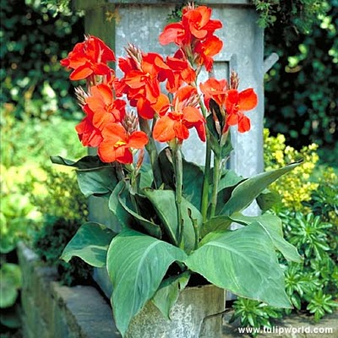
A native of the northern and southern hemisphere, they do well over most of the United States, provided there is plenty of heat. They are very dependable, easy to plant and easy to grow. They are now regaining much of the popularity they once enjoyed as an old garden perennial.

Their colors range from ivory, yellow, rose, salmon and red with green or bronze foliage and can reach from 3 to 6 feet tall.

Cannas may be planted in the spring after danger from hard frost, in a loose, fertile, well-drained soil. Improve the soil with peat moss and compost. Plant 12 to 16 inches apart by laying the root horizontal to the earth’s surface, with eye up, if visible. Cover with 2 to 3 inches of soil.

For best results in colder regions, roots can be planted in pots (6-8 weeks before spring) and kept indoors, until all danger of frost is past. You can then plant them outside. Cultivate often to keep soil loose and free of weeds.

Cannas should be watered thoroughly as needed by slowly soaking the area around the roots. For optimum performance, add a general all-purpose fertilizer (5-10-5 or 11-15-11) every 4 to 6 weeks during growing season. Cut old spent flowers and seedpods to induce repeated flowering late into the autumn season.

OVER WINTERING

Dig up clumps of roots in the fall, after the first frost, for replanting the following spring. Two methods of storage are:
- Remove old stalks and leave roots in clump with soil intact. Pile up clumps and cover with plastic and store in basement.
OR

- Bulbs can be washed, divided, dried and layered with vermiculite or peat moss in waxed boxes with lids or in plastic bags to prevent drying out. Store in basement or other cool place at 35-45 degrees, keeping the vermiculite barely moist.

