

NURSERY, GARDEN CENTER, GREENHOUSE & PATIO
5150 Garrison ST. Arvada, CO 80002 303-424-7979
www.echters.com

CITRUS CARE
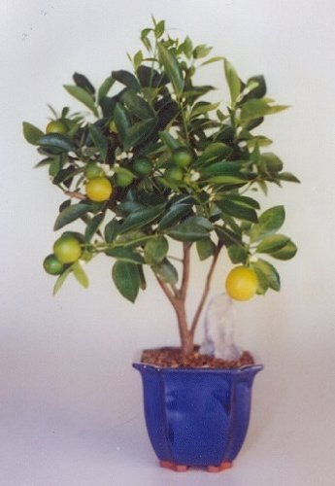
Grow your own lemons, limes, oranges, grapefruits, kumquats and tangerines on small bushes or trees. The many white flowers fill the room with a wonderful fragrance. Find your sunniest spot and these plants should do very well.

Temperature: Average warmth and not less than 50°F in the winter.

Light: Full sun (6-8 hours of direct light for best performance)

Water: Water thoroughly all year allowing the top 1/3 of the root ball to become dry between waterings. Increase watering frequency once fruit has set, as some water is being directed straight into the developing fruit—the plant will be using water more quickly. Don’t water again until the top of the soil has dried out.

Pot Size: Avoid “over-potting” your citrus by immediately planting it in a large pot. It may be a tree in time, but these are young plants with a small root system. Stick with a container that has drainage holes and is no more than 3” wider than the previous pot. Repot every 2-3 years.

Fertilize: Use Jack’s Classic Citrus Feed or an acid plant food at ½ strength every other time you water.

Fruiting: Citrus plants set many flowers but few will progress to becoming a fruit. Flower clusters will become clusters of tiny fruits, and most of these will naturally drop off the plant. As long as the plant retains 1-2 fruits per cluster the plant is on-track.

It takes long time for citrus fruit to ripen. Lemons and oranges will get to full size and then stay green for months. Don’t be discouraged! This is normal.

Citrus plants purchased at a nursery are self-fertile and do not need assistance with the pollination process. Flowers will pollinate themselves naturally.

Citrus require good drainage, careful watering, ample feeding, full sun, summer spent outdoors and cool conditions in winter. Check for any insects before bringing indoors in early Fall.

