

NURSERY, GARDEN CENTER, GREENHOUSE & PATIO
5150 Garrison St. Arvada, CO 80002 303-424-7979
www.echters.com

Clematis Care Sheet
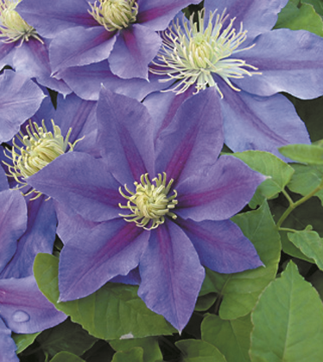
Plant clematis in Spring, Summer or early Fall in a location which will receive at least 5-6 hours of sunlight. Clematis roots are long and deep and prefer cool, damp soil. Planting annuals or small shrubbery around the base of the vine will provide cooling shade for the roots. A 2” (5 cm) layer of mulch, preferably shredded cedar bark or pine bark will aid in moisture retention. Shredded leaves or pine needles are also acceptable.

When planting, excavate the soil to a depth and width of 18” to 24” (45 cm). Amend the excavated soil with a mixture of sphagnum peat moss and compost by one third the volume of soil. Additional compost can be forked into the base of the excavation. Return the amended soil to the hole and set the plant with the crown 1 ½” to 2” (5 cm) beneath the soil level.

Stake the plant carefully and guide it towards its permanent support. A redwood trellis would be a good choice. Water freely and often the first year, but avoid keeping the soil soggy. In subsequent years, be sure to water deeply every 7-10 days in dry weather.

Feed twice a season with a good fertilizer, such as Colorado’s Own Vegetable & Flower Food 5-10-5, Colorado’s Own Flower and Garden Food 6-10-4 or Peters Professional Soluble Plant Food 15-20-15. April and July are good months for feeding the early blooming varieties. April and June are best for late blooming varieties. Make sure vine is well watered before feeding. Feeding should be stopped just before flowering starts. To continue feeding into the bloom period will cause flowers to mature rapidly and shorten the flowering period of the plant.

If mulch has deteriorated by the Fall, add additional protection for the winter. A 2” (5 cm) depth is adequate.

Jackmanii Cultivars:

Hard Pruning Varieties

These flower continuously on young wood and should be cut back to the lowest pair of buds on each stem, which is often to within a few inches of the ground on young plants. If left unpruned, Jackmanii cultivars will start to grow from where they left off last year or to the point of winter kill that will leave bare stems at the base of the plants.

Clematis integrifolia:
C x.Durandii C. tangutica
C orientalis ‘Bill Mackenzie’ C. recta
C. texensis ‘Graveyte Beauty’ C. x jackmanii
C. viticella ‘Etaille Vialette’ C. x ‘Ascotiensis’
C. viticella ‘Polish Spirit’ C. x ‘Cardinal Rouge’
C. x ‘Comtesse de Bouchard’ C. x ‘Ernest Markham’
C. x ‘Gypsy Queen’ C. x ‘Hagley Hybrid’
C. x ‘Jackmanii Rubra’ C. x ‘Niobie’
C. x ‘Pink Champagne’ C. x ‘Perle d’Azure’
C. x ‘Star of India’ C. x ‘Ville de Lyon’

May, June Flowering Clematis:

The following varieties of clematis flower in May and June on the previous years vine and need little pruning. Some of these will flower again later in the summer on vine produced after the initial bloom. Some light pruning can be done in Spring to remove dead wood from the winter. Generally, except for winter kill, little pruning is required.

C. x ‘Lanuginosa Candida’ C. x ‘Bee’s Jubilee’
C. x ‘Belle of Woking’ C. x ‘Dr. Rupel’
C. x ‘Marie Boisolette’ C. x ‘Tillicum’
C. x ‘General Sikorsky’ C. x ‘Henryii’
C. x ‘John Warren’ C. x ‘Mrs. N. Thompson’
C. x ‘Mrs. Chomondely’ C. x ‘Prince Phillip’
C. x ‘Nellie Moser’ C. x ‘Ramona’
C. x ‘Proteus’ C. x ‘The President’
C. x ‘Silver Moon’

Fall Blooming Clematis:
Clematis paniculata, the autumn clematis, need little or no pruning unless space is limited, in which case it can be pruned hard.

