NURSERY, GARDEN CENTER, GREENHOUSE, & PATIO

5150 Garrison St. Arvada, CO 80002 303-424-7979
http://www.echters.com/

CONTAINER IDEAS

Personalize your planter with unusual containers and accessories. If you are a music lover, try punching holes in the bottom of an old guitar or violin case, lined with plastic. If country is your theme, try hollowing out a bale of hay. The hay will retain moisture well and still provide good drainage. For a more sporting theme, try using an old golf bag, tackle box, or boxing gloves for a hanging planter. Old watering cans, wheelbarrows, metal pails, crocks and even decorative tea pots are suitable for container planting. If cooking is your hobby, try using a large colander or accenting an herb pot with kitchen gadgets. Container gardening is only limited by one’s imagination. Just be sure that your container is the appropriate size for your project, provides good drainage for proper plant growth and suits your personality.

Al’s Flower Pouch is a unique way to create a container less look. These hang neatly on doors, walls or fences. For the front door, try placing a half basket inside a wreath. Fill it with your favorite vine to wind through the wreath and cascade out of the container.
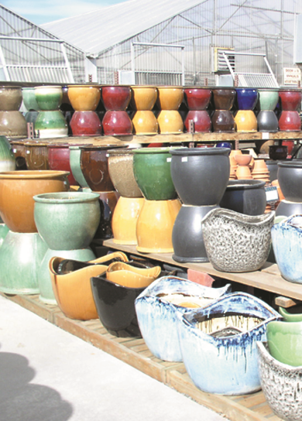
Of course there is always an excellent selection of pottery and barrels available at the garden center. Pottery need not be used as a single pot. For added interest and height, stack graduated sized pots atop the soil in the center of the preceding container. This will allow for a cascading appearance and creates quite a showpiece. Should you stack more than three pots on top of each other, you may wish to drive a stake through the drainage holes to stabilize the tiers.

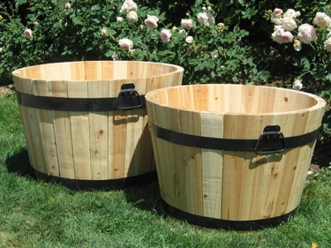
Whiskey barrels are an excellent choice for large, informal flower gardens, but they are also perfect for container vegetable gardening. On barrel can contain several tomato plants or bush beans, trellis supported pole beans, and artichokes, peppers, lettuce, spinach …. Just about anything. Place one near a door and fill it with herbs for easy access from the kitchen.

If you would like to have a water garden without the actual pond, use a ceramic pot without a drainage hole, or cork it and seal it. Fill it with water, a pump for circulation, water hyacinth or water lettuce, and your choice of water plants. This type of water garden is the perfect size for the patio, porch or a quaint niche in the garden. Liners may be purchased for whiskey barrel to create a portable pond.

Containers may also be used to display more fragile ornamental trees and shrubs during the summer. Be sure to check with our nurserymen on the details of over wintering these items. Some flowering trees and shrubs, as well as dwarf fruit trees are more suited to this type of growing habit than others. This can, however, provide interest and structure to sprawling patios and decks.
SUGGESTED ANNUAL FOR DECORATIVE CONTAINERS

SUN:
Ageratum, Alyssum, Bougainvillea, Cannas, Celosia or Cockscomb, Dahlias, Dolichos Lab-Lab, Gardenias, Gazanias, Geraniums, Hibiscus, Kochia, Lantana, Marguerite Daises, Marigolds, Miniature Roses, Moon Vine, Morning Glory, Oxypetalum, Nolana, Pennistetum Rubrum, Penstemon “Sour Grapes” or “Ruby”, Petunias, Portulaca, Salvia, Santolina, Scarlet Runner Bean, Silene, Spikes, Springerei, Sweet Pea “Explorer Mix”, Sweet Potatoe “Marguerite” or “Blackie”, Thubergia, Verbena, Vinca Vine.

PARTIAL SUN:
Bacopa, Balsam, Begonias, Brachycome, Campanula “Stella Blue” or “Stella White”, Coleus, Convolvulus, Dallas Fern, Double Impatiens, Fuchsias, Gardenia, Hebe “Margaret”, Helichrysum White Licorice, Ivy Geraniums, Jasmine, Lobelia, Lysmachia, New Guinea Impatiens, Nierembergia, Night Blooming Jasmine, Pansies, Pansy Leaf Geraniums, Purple Bell Vine, Regal Geraniums, Scaevola, Schizanthus, Solar Series Coleus.

SHADE:
Bacopa, Balsam, Begonias, Browallia, Campanula, Coleus, Dallas Fern, Double Impatiens, Fuchsias, Impatiens, Labium, Lobelia, Metha, Pink or White Splash, Spikes.

HERBS:
Apple Mint, Banana Mint, Bolivian Rainbow Peppers, Chamomile, Chives, Cinnamon Basil, Coriander, Curry, Garden Sage, Ginger Mint, Ginger, Lemon Basil, Lemon Grass, Lemon Thyme, Paper Dragon Chilies, Parsley, Peppermint, Pineapple Sage, Purple Ruffles Basil, Rosemary, Siam Queen Basil, Spearmint, Stevia, Sweet Basil, Thai Peppers, Tri-color Sage, Watercress.

Ask about our annuals sales staff for more information about these plants and for further selections.

