
NURSERY, GARDEN CENTER, GREENHOUSE & PATIO
5150 Garrison St. Arvada, CO 80002 303-424-7979
http://www.echters.com/

Cyclamen Care
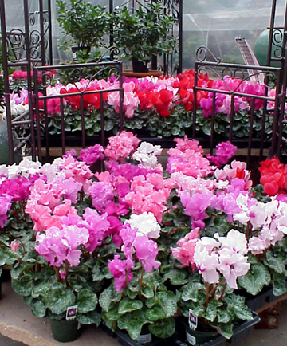
With proper care, cyclamen will bloom indoors for several months and can be kept through the summer to provide another display of blossoms next winter. Choose a plant with plenty of unopened buds to get the most flowers this season. This plant does best in a cool room and in bright light, but away from direct sunlight. A north or east-facing windowsill is ideal.

Temperature: Cool, 50° to 60°F is ideal.

Light: Bright light, but away from direct sunlight.

Water: Keep the soil moist at all times. Water from the bottom or very slowly from the top.

Humidity: Sit the pot in a pebble tray (a tray filled with water and pebbles), but don’t let the plant sit in the water. Do not mist the plant.

Fertilizer: Use a high phosphorus fertilizer such as Jack's Blossom Booster at 1/4 teaspoon per gallon, and use it every time that the plant needs water.

General Care: Remove faded flowers and old leaves. After the plant has stopped blooming, reduce watering and stop feeding. Place the pot in a cool spot and keep it dry until July. Then repot the cyclamen tuber in fresh compost, burying the tuber to half its depth. Place the pot in a cool, well-lit spot and water to keep the soil moist.

