

NURSERY, GARDEN CENTER, GREENHOUSE & PATIO
5150 Garrison St. Arvada, CO 80002 303-424-7979
www.echters.com

Dividing Hardy Water Lilies

Hardy water lilies, if grown in containers, require division every year or two. In the South, most lilies benefit from yearly division and in colder climates, division is not necessary as often. Overgrown lilies in need of dividing do not bloom. They produce smaller and smaller leaves from multiple growing points in the rootstock. The plant has a congested appearance and leaf color may be yellowish. The lily’s container may be so full of roots that it is difficult to insert Lilytabs fertilizer tablets. Division usually restores vigor and bloom. The best time to divide a hardy water lily is in the spring. They may be divided at other times of the growing season, but usually will not bloom for three to four weeks afterward. Many water gardeners divide and repot their lilies every spring when they clean the pool.

Procedure:
- Remove the plant from the container and rinse off all soil. Plant will have a main growing tip and some secondary juvenile growing tips visible on a large rootstock.
- Cut off (or break off) old rootstock end, leaving 4” to 6” of healthy rootstock with the main growing tip. Cut off juvenile crowns. Discard old woody rootstock end. Please see illustration.
- Repot trimmed rootstock, following planting instructions below. Use fresh, rich topsoil and Lilytabs fertilizer tablets. Juvenile crowns or growing tips may be discarded or potted in a small (1 gallon flower pot) container and grown in shallow water for a season. They will be blooming size plants in one year or less.

Planting Instructions:
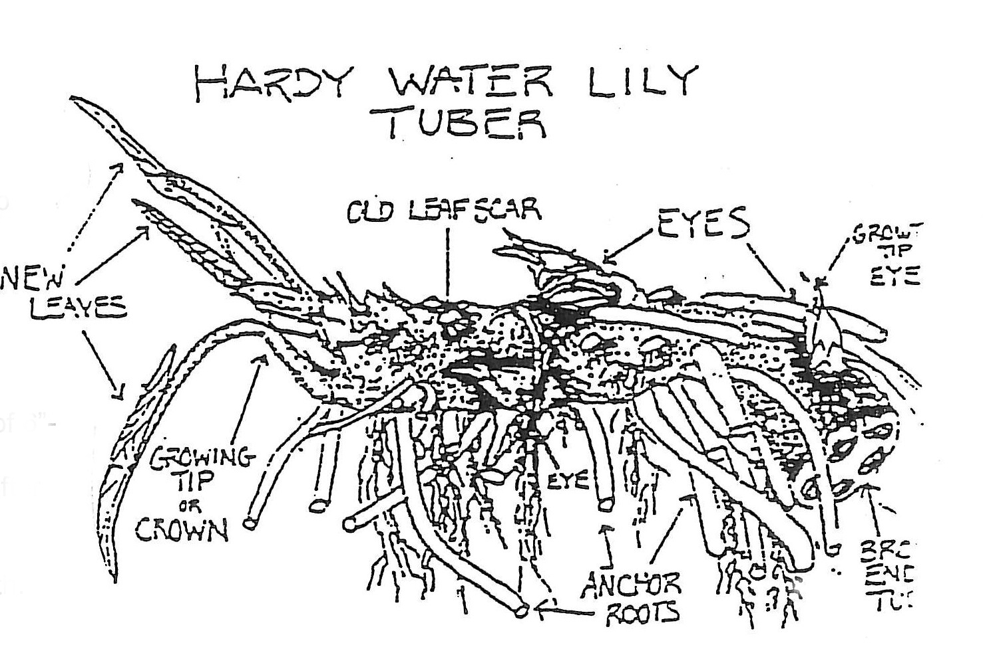
- Fill container 1/3 full.
- Push in Lilytabs.
- Add enough soil to ½ full.
- Position lily.
- Gently add soil around roots and tamp down.
- Keep growing crown (at top of root formation) free of soil.
- Thoroughly saturate soil with water.
- Cover soil with ½” pea gravel, again keeping crown free.
- Lower potted lily into pool to a depth of 6”- 18” of water over soil surface.
- Lilies require 2-3 weeks adjustment after planting before new growth resumes.
- Soil and Lilytabs may be increased (decreased) for larger (smaller) growth.

