

NURSERY, GARDEN CENTER, GREENHOUSE & PATIO
5150 Garrison St. Arvada, CO 80002 (303) 424-7979
www.echters.com

ECHINACEA PURPUREA

Purple or White Coneflower

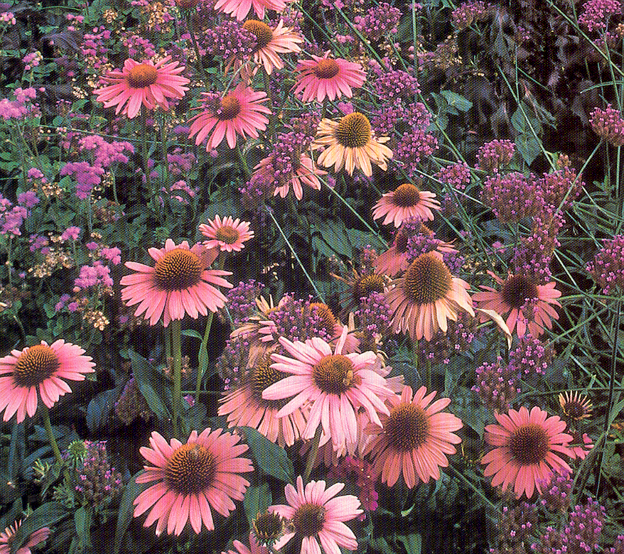
Coneflowers might well be known as the `workaholics’ of the perennial garden. They remind me of the little pink rabbit with the drum; once they get started they just “keep on going”. Bloom will not usually start until late June, but will generally continue until frost. And for those gardeners who want winter interest the sturdy seed heads will stand sentinel, providing structure for snow and birds.

The purple coneflower may be very familiar to most gardeners. It has been joined in recent years by a white-flowered counterpart. Both are highly useful as accent in the garden, as long lasting cut flowers and as dried material for everlasting arrangements. For those of us here in Colorado searching for reliable, drought tolerant perennials this plant is a `must have’. It is hardy to USDA Zone 3, so our winters are no problem. A location in full sun is usually suggested, however I have seen it growing beautifully in light shade.

The distinctive daisy flowers and rigid structure provide pleasing contrast with daylilies, Limonium (sea lavender), coreopsis `Moonbeam’, gypsophila, or other perennials with finer texture. The purple coneflower is quite stunning combined with the silver or gray foliage of artemesias. Planted together in large clumps, the purple and white will create a sensational display of summer color. Echinacea purpurea is readily available at most garden centers. It will be a great addition to your garden.

