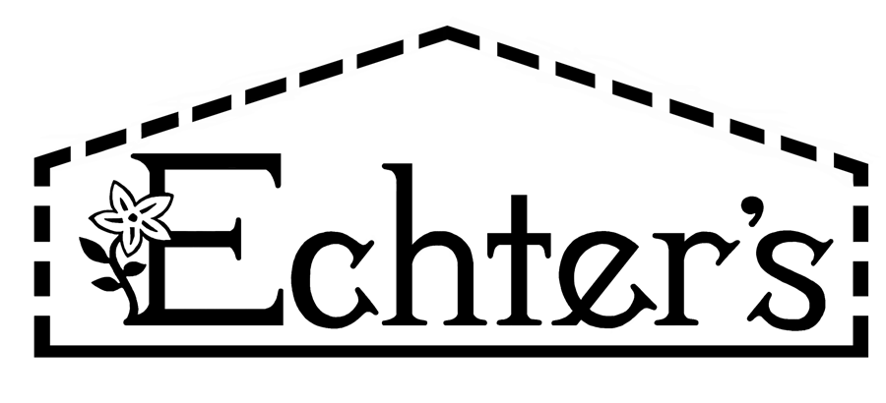

NURSERY, GARDEN CENTER, GREENHOUSE & PATIO
5150 Garrison St. Arvada, CO 80002 303-424-7979
www.echters.com

Echter’s Premium Lawn

Grass Seed Mixture

20% Bartitia Kentucky Bluegrass
30% Barzan Kentucky Bluegrass
20% Alene Kentucky Bluegrass

30% Turf Star Perennial Ryegrass

Sow Rate: 4 to 5 pounds per 1,000 square feet

Beautiful blend of the newest and finest improved Kentucky bluegrasses and Turf Star perennial ryegrass. Naturally low-growing, cool-season grasses with fine-textured leaves and a dark-green coloring.

Grows in sun or moving shade, quick to germinate, and greens up early each spring. Echter’s Premium Lawn mix forms a dense, aggressive turf with superior spreading habits. Show drought-tolerance and lower maintenance after establishment. A hardy mix that performs well under the stress of extreme cold and summer heat.

This durable mixture holds up well under foot traffic because of its superior recuperative capabilities.

Shows improved disease resistance to powdery mildew, stripe smut, brown patch, fusarium blight, dollar spot, crown rust, stem rust, leaf rust and leaf spot. Contains lolium endophyte fungus to provide insect resistance. Endophytes are a naturally occurring fungi that grows inside the grass plant and is transferred from plant to plant through the seed. Insects modify their feeding habits to avoid grass plants with endophyte fungi. This turf grass mixture should not be planted where cattle, horses, sheep or large wildlife might graze.

Prefers a well prepared soft loam, but is adaptable to thinner soils. Will grow in less than perfect conditions. For a beautiful, carpet-like sod, Echter’s Premium Lawn mixture requires supplemental irrigation and regular fertilization with a high-nitrogen fertilizer supplemented with iron. Do not allow this mixture to go into the winter months dry. Plant seed March through early October.

