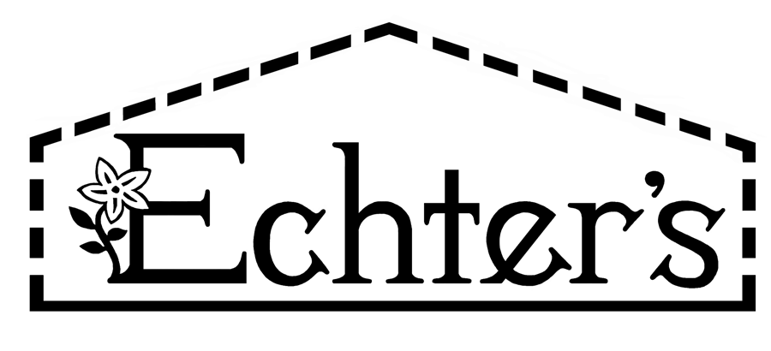

NURSERY, GARDEN CENTER, GREENHOUSE & PATIO
5150 Garrison St. Arvada, CO 80002 303-424-7979

www.echters.com

Fall Lawn Care

Feeding your lawn in the fall is probably the most important feeding of the year. Spring fertilizing begins in the fall, usually late fall. Feeding with a well-balanced winterizer will help build carbohydrate reserves in the root system for an early spring greening. This thick and quick green up in the spring will also hamper weed growth.

N-P-K: Nitrogen, Phosphorus, and Potassium (or Potash)
Nitrogen normally enhances vigorous top growth. Winterizers usually promote little top growth because of the time of year. The roots will store the carbohydrates until early spring or until conditions are right for them to be used. Then, WHAM!, you are mowing!

Phosphorus is usually associated with rooting and blooming. Turf processes phosphorus mostly for root growth. As we apply lawn fertilizer throughout the season, we’re constantly applying phosphorus. Phosphorus doesn’t move through the soil very well, staying where you put it. Also, the phosphorus is not absorbed as readily as nitrogen. As a result of this, studies at C S U and other agricultural colleges have found that winterizers only need a light percentage of “P”.

Potassium or Potash is our final friend in the analysis sequence. This chemical is used to strengthen lawn resistance to drought. It helps build the cell structure of the grass. Potassium also helps turf ward off insects, disease and traffic. The old school of thinking was that a high percentage of potassium in winterizers was wrong. Winterizers actually need a fair amount of potash.

W.I.N.: Water Insoluble Nitrogen is a form of slow release nitrogen that does not lend itself to being flushed from the soil easily. A high percentage of W.I.N. means it is less likely to burn.
Ammoniacal Nitrogen: fast release. This form of nitrogen is used up very quickly. Usually it’s found in smaller amounts of the total nitrogen percentage.
Urea: slow release nitrogen. Urea is processed within 6-8 weeks.
Sulphur coated urea: very slow release nitrogen. This form of nitrogen is processed within 10-14 weeks.

Quality Winterizers Featured at Echter’s
Ferti-lome Winterizer 25-3-6 with minors
Pro Rich Winterizer 14-2-4 with 1% iron
Jirdon’s Winterizer 18-6-12 with 1% iron/10% sulphur
Colorados Own Natural Winterizer 12-4-6
Colorados Own Winterizer 21-7-11
Scotts Winterizer 19-3-12
Mowing and Aeration

Optimal mowing height is 21/2”-3”. Fall aeration is also highly recommended. After aerating, rake the plugs away to alleviate accumulated thatch. If the soil attached to the plug dissipates, that’s fine. The key is to get up the spongy part: thatch and mat. The buildup of thatch and mat prevents air, moisture, and nutrients from getting down to the root zone. This accumulation of thatch and mat also adds to the “bumps in the lawn” caused by earthworms rising to the surface for air and moisture.

The customer must also be reminded about watering during the winter months. Colorado has plenty of warm winter days (50%-70%), so dry spells and/or high wind conditions make it imperative that we water not only lawns, but perennials, roses, shrubs and trees, too. Lawns outfitted with sprinkler systems need to be augmented with a manual sprinkler that can be moved easily. Most winterkill in Colorado landscapes is caused by too little water.

Sodding and seeding lawns in the fall is the best time of year to do it. Cooler temperatures help the grasses get established. When installing a newly seeded or sodded lawn in the fall, we recommend a starter fertilizer, which has a higher phosphorus content to help establish root systems such as Fertilome’s New Lawn Starter 9-13-7. We normally carry sod until the first or second week of October, depending on the weather.

