# 

**NURSERY, GARDEN CENTER, GREENHOUSE & PATIO**

5150 Garrison St. Arvada, CO 80002 303-424-7979

[www.echters.com](http://www.echters.com)

# Espalier Training on Young Fruit Trees

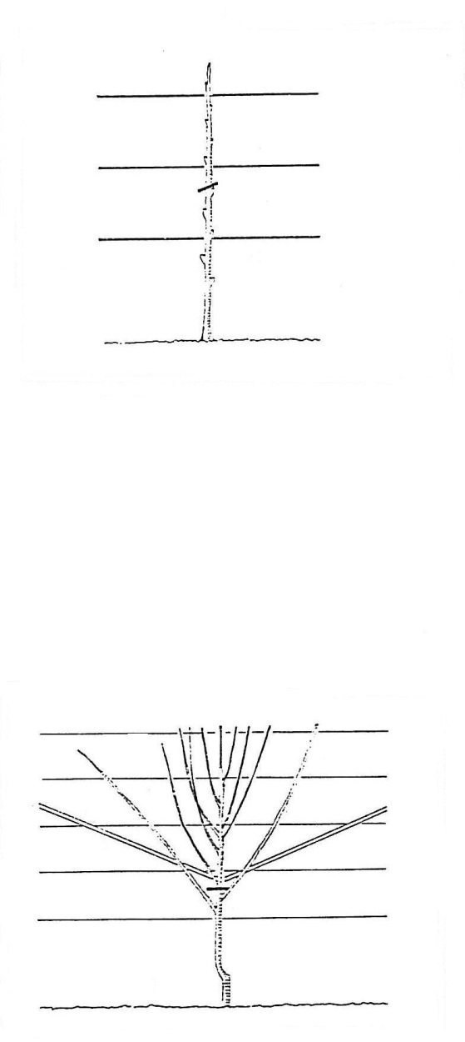This common form of espalier helps early blooming fruit trees to cope with the late frosts so common to our late springs. Peaches, apricots and cherries are especially beautiful, but any small tree can be grown this way.

The object is to prune and train the tree to grow in a single vertical plane, parallel to a wall. The wall will help to moderate the temperature swings, especially if the wall faces south or west away from strong winds.

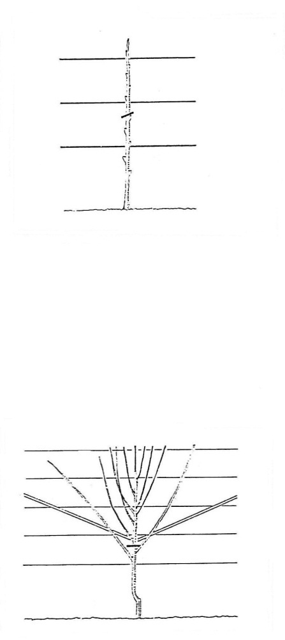Build a trellis of sturdy, horizontal wire stretched between two 2x4 uprights flanking the tree. Start the wires 2 feet above the ground and space them 6 inches apart. Choose a tree with two to four opposing side branches. Make sure the branches are symmetrical on either side of the trunk.

Cut the leader above the uppermost branch and remove any other branches below by pruning them to the trunk.

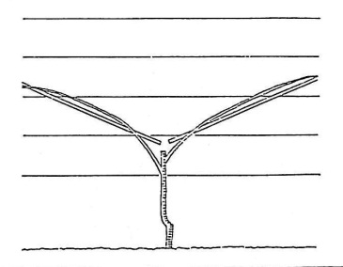In late winter, prune the saved branches back to between 18-24 inches, with the lowest branches longer than the upper branches.

Tie the branches to the wires for support and shape. In summer, choose 3-4 well placed side shoots on each branch and tie them to the wires. Remove other shoots, and repeat this procedure each following summer to fill out the fan.

Start pruning for fruit once the tree is 2-3 years old.

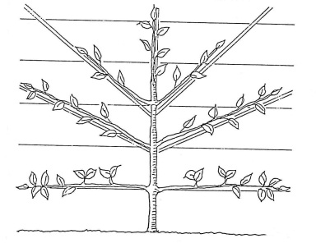Fruit is born only on last year’s shoots, so to identify the fruit buds by looking for a cluster of up to three buds (they are plumper than the leaf buds).

Do not let all the fruit (flower) buds produce, because this will reduce the fruit size, strain limbs, and requires more energy from the tree. Evenly thin out two-thirds of the fruit buds. Once those shoots produce, remove them the following winter.

Tie new shoots to the wires for next year’s bounty.