

NURSERY, GARDEN CENTER, GREENHOUSE & PATIO
5150 Garrison St. Arvada, CO 80002 303-424-7979
www.echters.com

FICUS CARE SHEET
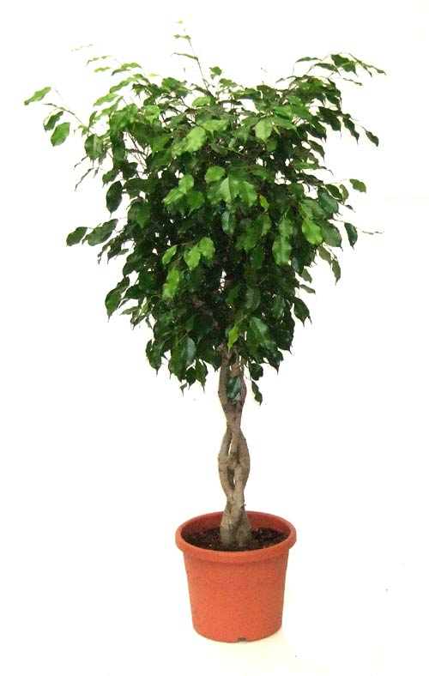
A huge genus with more than 800 species, most of them originating in Asia and Africa. The larger species make a graceful, indoor, tree-like plant, while the trailing types make useful plants for hanging pots.

Some popular tree types are Benjamina, Lyrata, Rubber Tree,. Trailing types include Creeping Ficus (green or variegated),and Oak Leaf.

TEMPERATURE: Warm - Prefers day temps of 70-75 degrees F. and night time temps of 65-70 degrees F. with a minimum of 55 degrees F. in the winter.

LIGHT: Tree and shrub types prefer a bright spot, but avoid direct summer sun through glass during the hottest part of the day. Partial shade for trailing and climbing types.

WATER: Water with care. With tree types the soil must dry out to some extent between waterings. The trailing types require more frequent watering. Water thoroughly with tepid water. Water all varieties regularly from spring to autumn, but sparingly in the winter. Do not allow plants to stand in water.

FERTILIZER: Feed regularly during active growing periods in spring and summer.

NOTE: Ficus benjamina are known to shock when they are moved. Expect leaf loss for a period of 4-6 weeks anytime the plant is relocated. Extra humidity will help ease the transition.

