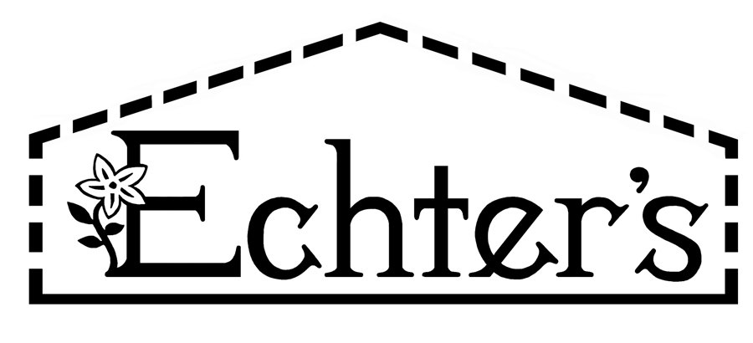
NURSERY, GARDEN CENTER, GREENHOUSE & PATIO
5150 Garrison St. Arvada, CO 80002 303-424-7979
www.echters.com

Fish Feeding Table

(Water Temperature)
34-48° F (1-9° C) No Feeding
50-54° F (10-12° C) Feed once a week
56-59° F (13-15° C) Feed once a day
61-86° F (16-18° C) Feed twice a day
Above 86° F (Above 30° C) Do not feed

Feed only what the fish will eat in 10 minutes.

Net the leftovers out.

