Arvada, CO 80002 303-424-7979



NURSERY, GARDEN CENTER, GREENHOUSE & PATIO
5150 Garrison St. Arvada, CO 80002 303-424-7979
http://www.echters.com/
www.echters.com

CHRISTMAS TREE CARE

Keeping Your Christmas Tree Fresh

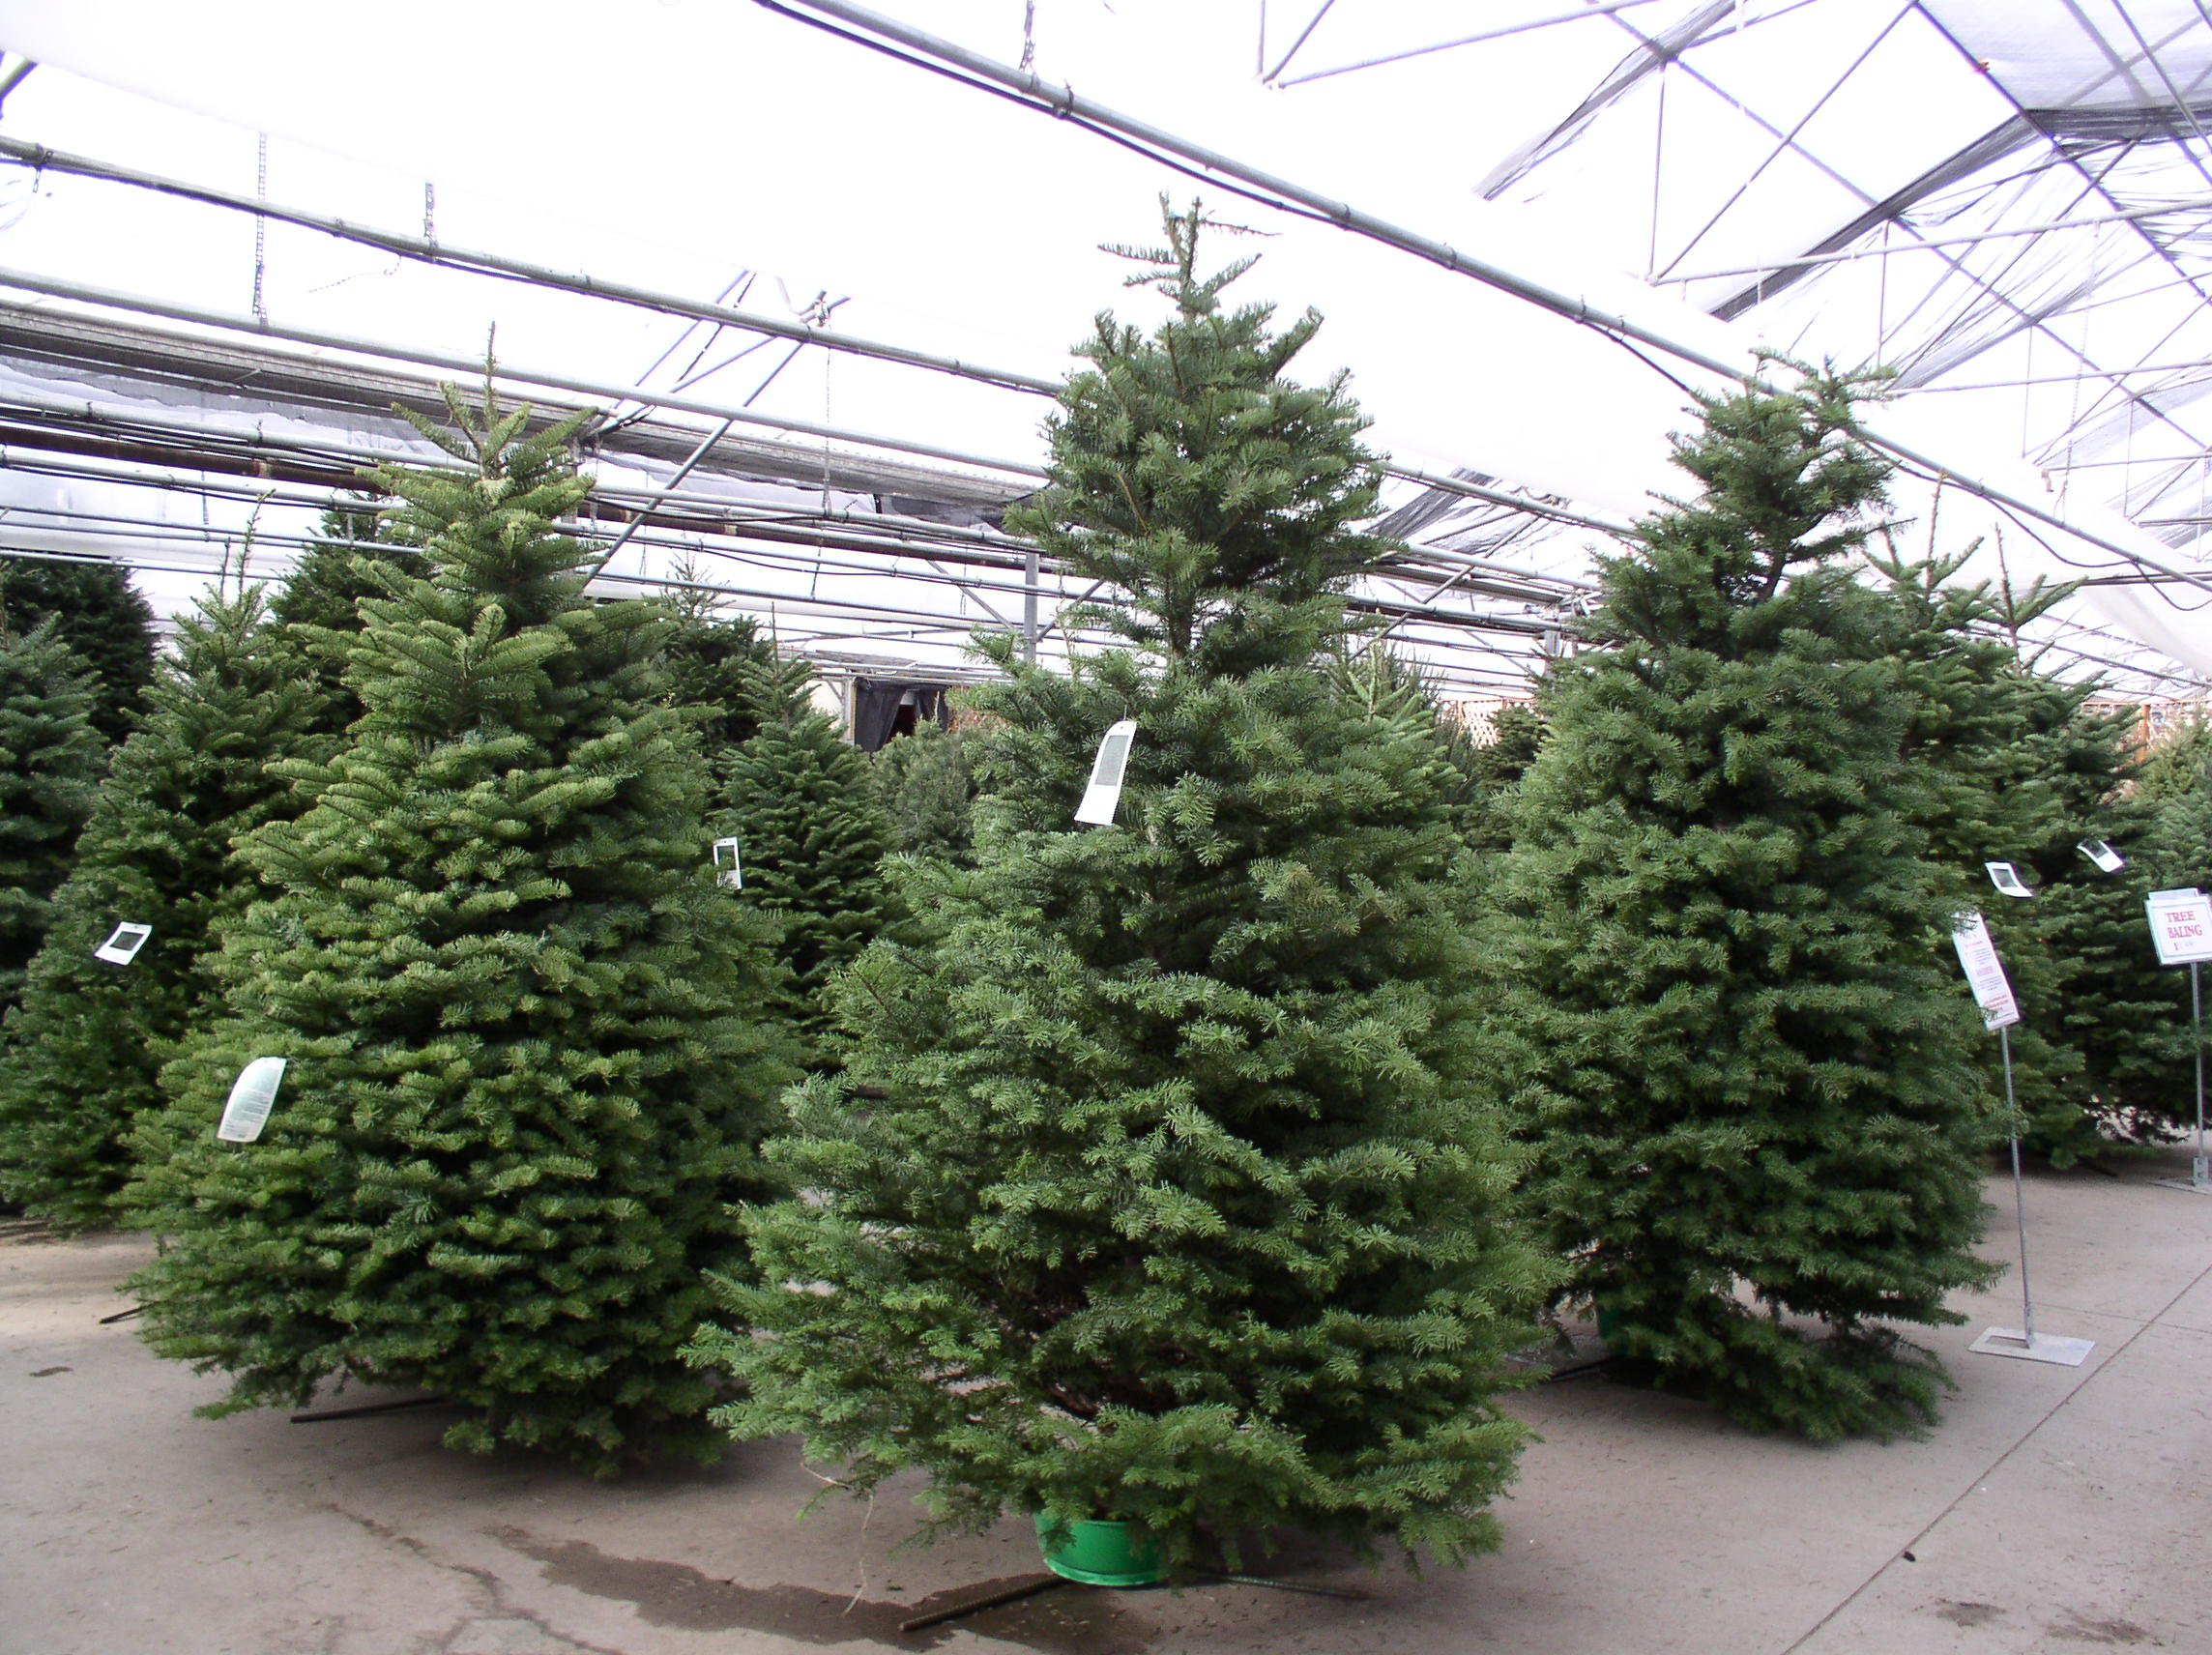
In order to keep your Christmas Tree as fresh as possible, we recommend the following steps:

- Take tree home and saw 2” off the bottom of the trunk.

- Immediately place tree in lukewarm water. Add “Keeps-It-Green” Christmas Tree preservative. A study made by Washington State University has found that “Keeps-It-Green” can significantly reduce needle loss.

- If tree is not to be put up right away, it is best to keep tree in a protected area, like a garage or covered patio, out of the sun and wind.

- Before you decorate, be sure the water level goes down in the reservoir, which means the tree is taking up the water. If it does not take up water, try re-cutting 1” off trunk.

- After tree is decorated, be sure the water level is not allowed to drop below the fresh cut of the tree trunk.

- The tree can also be kept fresher by keeping the tree out of direct sunlight and be sure heat registers closest to tree are kept closed.

HAPPY HOLIDAYS!

