

NURSERY, GARDEN CENTER, GREENHOUSE & PATIO
5150 Garrison St. Arvada 303-424-7979
http://www.echters.com/

Fuchsia Care Sheet

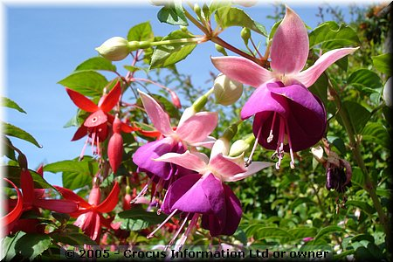
Fuchsias will continue to bloom beautifully until first frost if they are grown properly. They are available in many colors and bicolors including white, violet, purple, pink, red and shades approaching orange. The flowers have no fragrance, but they do attract hummingbirds.

The most popular ones by far are the trailing varieties for hanging baskets. Some varieties naturally grow upright for containers and flower beds. Any of them can be trained to grow in a tree form.

Best Environment: Fuchsias need to be protected from frost. If you put them out before May 20, you may need to cover them or bring them inside if we have a late cold snap. Fuchsias grow best in cool temperatures with little or no direct sunlight. Protect them from drying winds and give them a regular supply of water and fertilizer. Fuchsias do not make good houseplants.

Watering: Water as often as the soil becomes slightly dry, however, never let a fuchsia wilt as this will contribute to bud drop. Hanging baskets need special attention as they can dry out quickly in hot summer weather. If foliage wilts in extreme heat regardless of watering, mist the plant to cool it down or move it to a cooler location temporarily.

Feeding: Apply Jack’s Classic Blossom Booster with every watering to keep them blooming.

Pinching: Pinching the tips off some longer branches forces growth into side branches making the plant bushier and improves blossoming. Pick off old flowers as they fade and never allow berries to form if you can help it. They reduce flower production.

Pests: Fuchsias can be bothered by aphids, spider mites, and whiteflies. If not controlled, they cause the leaves to yellow and drop.

