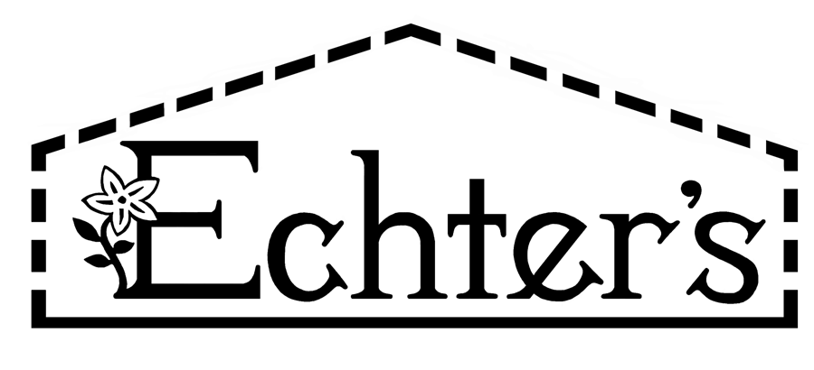

**NURSERY, GARDEN CENTER, GREENHOUSE & PATIO**

5150 Garrison St. Arvada, CO 80002 303-424-7979

[www.echters.com](http://www.echters.com)

**Fungicide Index**

**Synthetically derived:**

* Boscalid – Bonide Fruit Tree + Plant Guard
* Captan – Bonide Fruit Tree Spray
* Chlorothalonil – Bonide Fung-onil
* Difenoconazole – Bonide Rose Shield
* Myclobutanil – FL F-Stop
* Propiconazole – FL Liquid Systemic Fungicide
* Pyraclostrobin – Bonide Fruit Tree + Plant Guard
* Tebuconazole – Bayer 3n1 Insect Disease + Mite Control, Bayer All in 1 Rose + Flower Care
* Thiophanate-methyl – Bonide Infuse

**Naturally derived:**

* Bacillus amyloliquefaciens strain D747 – Bonide Revitalize
* Bacillus subtilis strain QST713 – Serenade Disease Control
* Copper – Bonide Copper Fungicide
* Neem - Bonide Neem Oil, Bonide Bon-Neem, Bonide Rose RX, FL Triple Action, GS Fungicide 3
* Streptomycin Sulfate – FL Fire Blight Spray
* Sulfur – Bonide Sulfur Dust, Safer Garden Fungicide