

NURSERY, GARDEN CENTER, GREENHOUSE & PATIO
5150 Garrison St. Arvada, CO 80002 303-424-7979
www.echters.com

GARDEN MUMS
Chrysanthemum x morifolium

General:
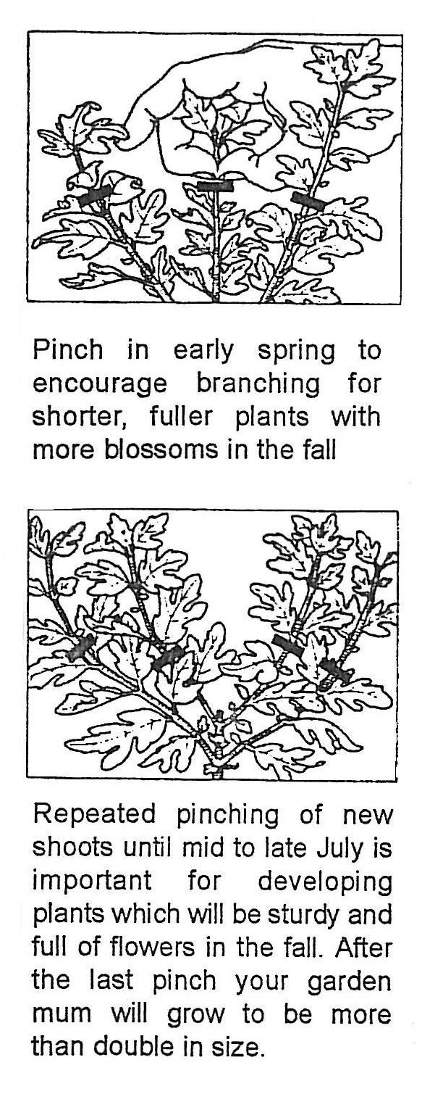
Garden mums, also known as Chrysanthemums, are grown as the plant best known for fall blooming. There are as many varieties available featuring distinctive flower shapes as well as a wide range of colors. The early varieties will begin blooming in August. Mid-season types will follow in late August or early September. Finally, the late varieties provide color into October and in some years, as late as November.

Culture:
Garden mums will perform best if planted in sunny locations with at least 6 hours of sun. Chrysanthemums are shallow rooted and require well-amended soils with good drainage. They should receive adequate moisture during prolonged dry periods. To prevent foliar diseases such as powdery mildew, avoid overhead watering. Mulches such as shredded bark or leaves or straw or dried lawn clippings are useful in conserving moisture and reducing weeds.

Pinching:
To encourage branching and development of compact, bushy plants it is very important to pinch back garden mums in the spring as soon as new growth is 4”-6” tall. Use your thumbnail and index finger to ‘pinch’ about ½ of the new growth at the top of each and every shoot. Repeat this procedure through the summer whenever new shoots are 3”-5” long. Stop pinching around July 10th -15th to allow the buds to finish developing for fall bloom. This repeated pinching will result in well-developed, sturdy plants full of flowers. After the last pinch, your garden mum will grow to maximum fullness.

Fertilizing:
Fertilize regularly from early spring through the summer with Jack’s Classic Blossom Booster (10-30-20) until the final buds show color.

Dividing:
Garden mums may need division in their second or third season or when the center of the plant begins to weaken and die back. This is best done in the spring while the plants are small. Lift the entire clump and divide into 3 to 5 divisions. Discard the woody center. Replant the new divisions about 18” apart.

Insects & Diseases:
Chrysanthemums are rarely bothered by pests or diseases. When problems do occur, a general combination insecticide/fungicide is a good preventative. Practicing good cultural conditions will reduce the incidence of problems.

