

NURSERY, GARDEN CENTER, GREENHOUSE & PATIO
5150 Garrison St. Arvada, CO 80002 303-424-7979
www.echters.com

GARDENIA CARE SHEET

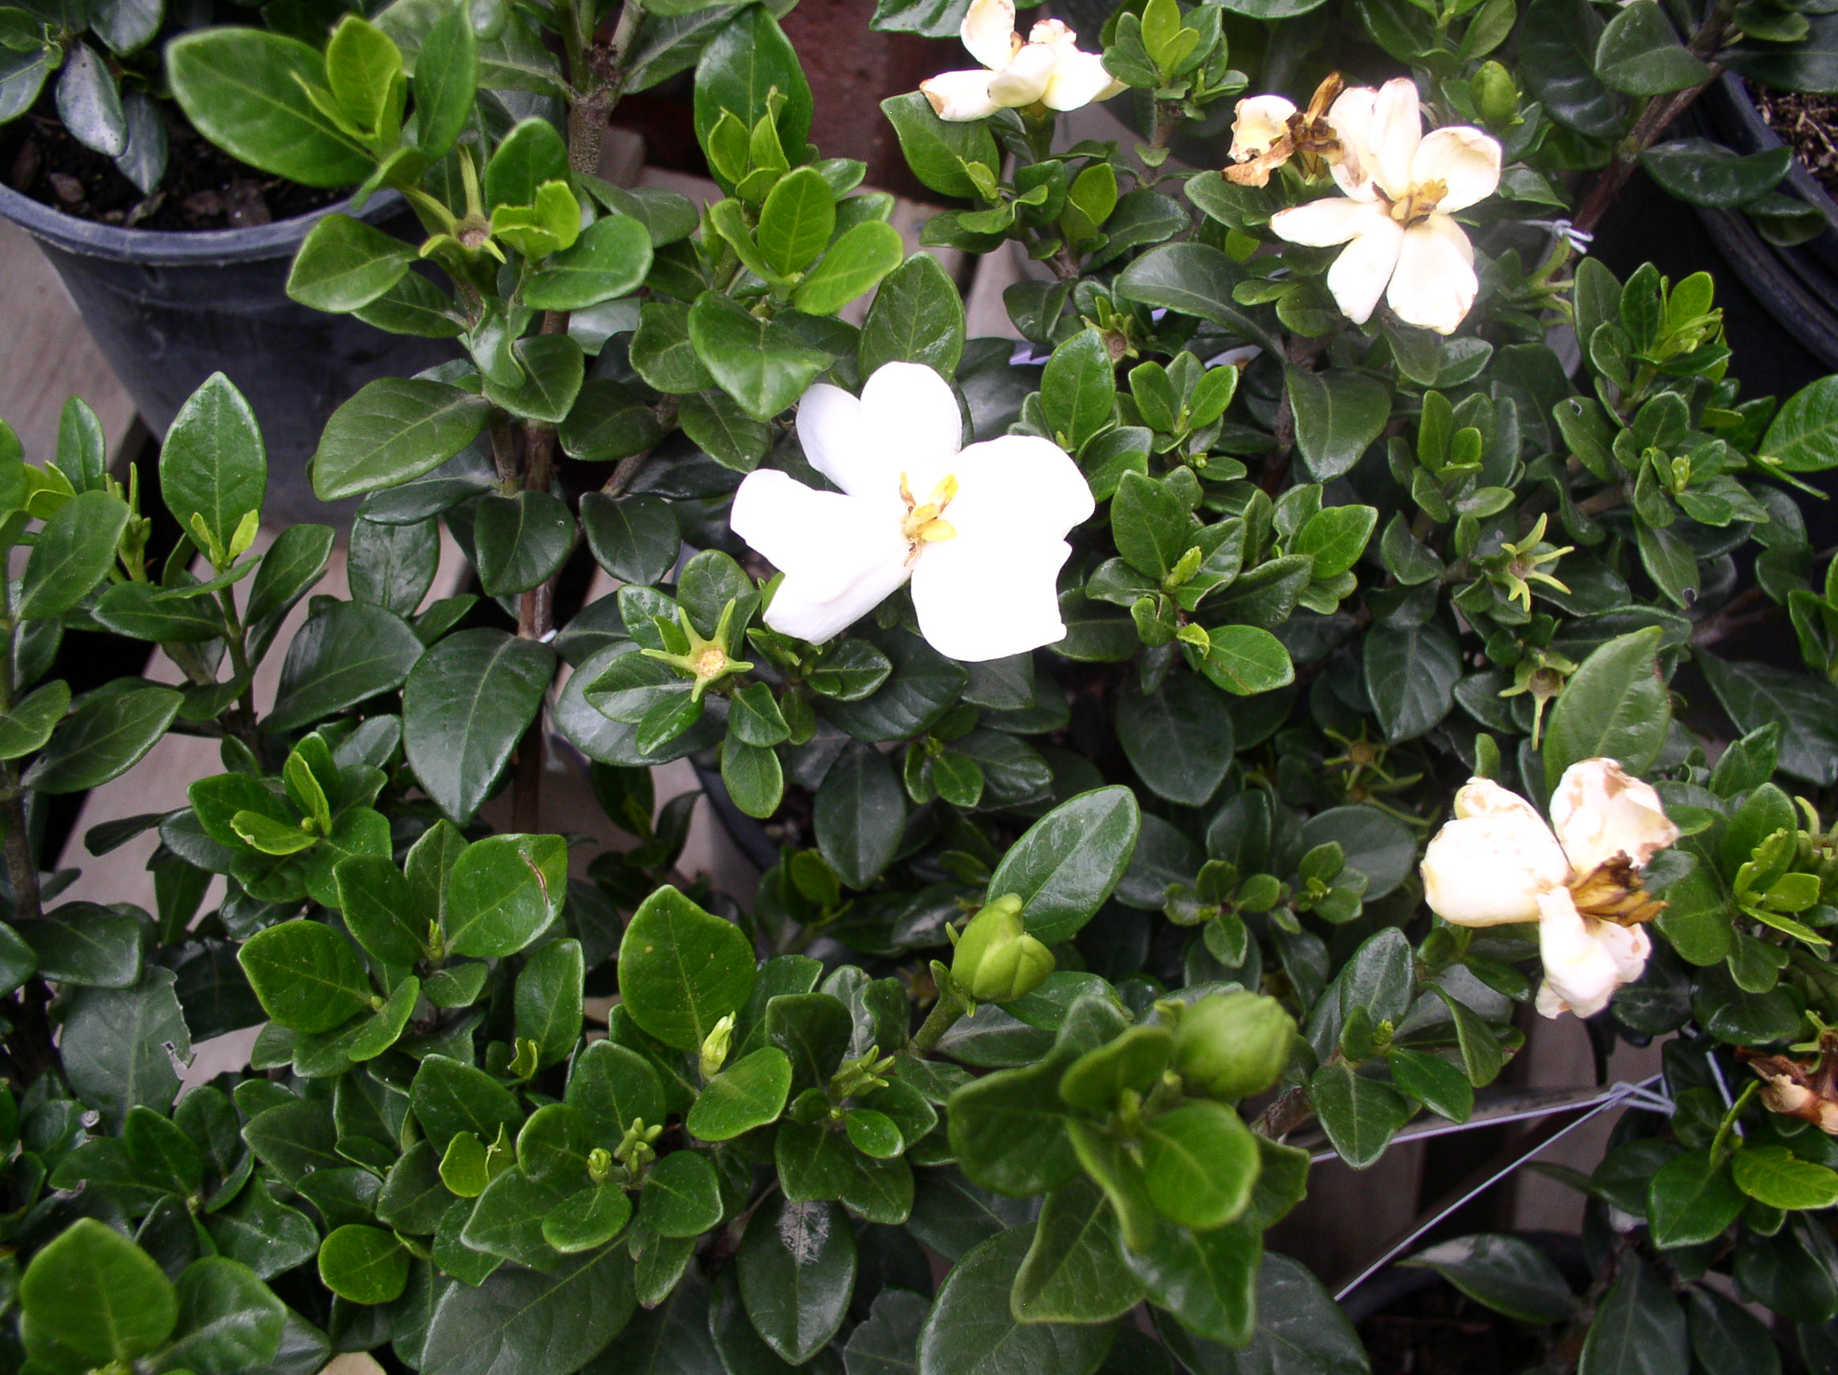
The gardenia can be a delight as an indoor foliage plant, but it may be temperamental. In the spring the large, waxy white flowers fill the air with a wonderful fragrance. Even without flowers, it is an attractive green plant.

TEMPERATURE: Average warmth. For flower buds to form a night temperature of 60-65F is required and the day temperature should be 10 degrees higher.

LIGHT: Bright light is essential, but avoid direct hot summer sun.

WATER: Water plant when slightly dry. Water thoroughly and discard drainage.
Use tepid water.

HUMIDITY: This plant requires humidity. Use a humidifier or pebble tray whenever possible. Do not mist.

FERTILIZER: Gardenias thrive in acidic Southern soil, so use an acid-loving fertilizer. Jack’s Classic Acid Special and Miracid are great options.

REPOTTING: Repot when needed in the spring. Use only the next size up pot to plant into. Echter’s Indoor Potting Mix is ideal. Propagate by cutting in the spring. Use Fertilome Rooting Powder to stimulate root production.

GENERAL INFORMATION: Pinch out stem tips to improve the form of the plant, but do not destroy flower buds. The leaves of this plant will drop if the soil is too wet or too dry. Flower buds will drop if the plant is stressed and during it’s acclamation period.

