

NURSERY, GARDEN CENTER, GREENHOUSE & PATIO
5150 Garrison St. Arvada 303-424-7979
http://www.echters.com/

Geranium Care Sheet
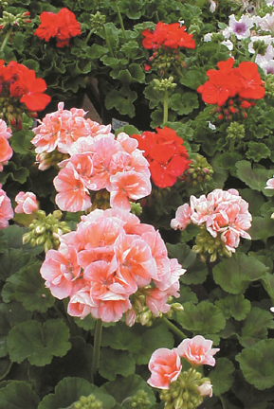
Geraniums are very popular flowering plants that can be used in flower beds, in patio containers, for hanging baskets, and as houseplants. There are four main types of annual geraniums: common or zonal geraniums, ivy geraniums, scented-leaf varieties, and regal geraniums.

The zonal geranium requires at least 6 to 8 hours of sunlight per day, loose well-draining soil, and a consistent supply of fertilizer. They can go slightly dry before watering. Old faded blooms should be removed and the stems should be pruned back to encourage new growth and vigorous blooms. They do very well in the summer heat.

Ivy geraniums make attractive hanging baskets or flowering ground covers. They prefer a shadier location with cooler temperatures than the zonal varieties.

Scented-leaf geraniums are grown primarily for their fragrant leaves. They prefer 6-8 hours of sunlight.

Regal geraniums have spectacular flowers. They grow and flower best under cool, filtered-sun conditions.

Geraniums are grown in protective greenhouses. They need to be hardened off for a few days by gradually exposing them to the full hot afternoon sun and drying winds.

If you are growing geraniums in containers or hanging baskets, use a good planting medium that is porous and lightweight, yet has good water-holding capacity like Echter’s Outdoor Container Mix (that’s what they are in now!). There must be drainage holes in the containers. Use Jack’s Classic Blossom Booster with every watering. Water thoroughly when the soil surface feels dry. Hanging baskets can dry out quickly due to the increased exposure.

Before planting geraniums into flower beds, amend new planting areas by adding some Nature’s Yield Compost For zonal geraniums choose a sunny, well-drained location.

Keep your geraniums in top form by snapping off faded flower stems and pinching back the long stems occasionally for a compact, bushy shape.

Gently break up the root ball when transplanting to initiate new root production.

Geranium budworms have been a pest in recent years. This pest will eat the geranium flower while still in bud, resulting in damaged flowers or no flowers at all. They can be safely controlled with Dipel spray or dust.

