

NURSERY, GARDEN CENTER, GREEN HOUSE & PATIO
5150 Garrison St. Arvada, CO 80002 303-424-7979
www.echters.com

Hardy Water Lilies
(Nymphaea)

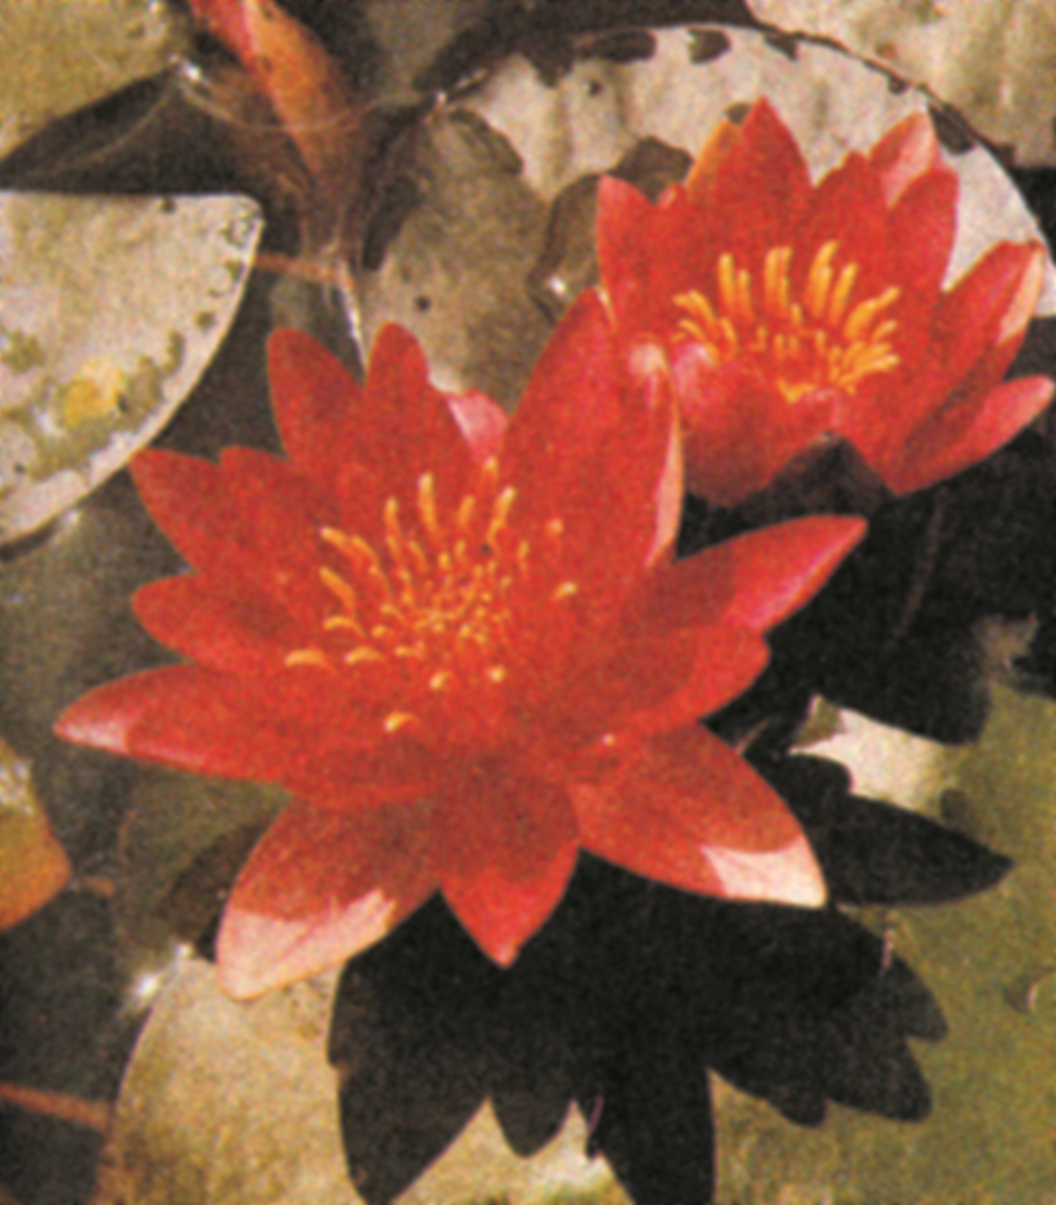
Hardy water lilies provide the water garden with continuous color from May through frost. The flowers come in many colors: subtle shades of red, rich arrays of pink, sparkling whites, exciting yellows and changeable sunset colors. The flowers rest tranquilly among the rich green or mottled lily pads. Most flowers float on the surface of the water. Several varieties also rise above the surface similar to tropical lilies. (These are identified in the lily descriptions.) The individual flowers of hardy lilies last up to five days.

The many varieties of hardy water lilies provide for a wide selection to fit your particular garden need. The flower size, color and foliage characteristics are identified in the description to help in your decision.

All hardy water lilies require a minimum of 4 to 6 hours of sunlight. Full sun is preferable.

Oxygenating Plants:

Submerged plants are essential to maintain proper balance in the pool. They add oxygen to the water and serve as a filter by absorbing dissolved nutrients and competing with algae. Oxygenating plants are essential for pools with fish. Not only do they help establish a natural balance in the pool, they also serve as a food source, spawning mats, and a hiding place for baby fish.

Planting Oxygenating Plants:

Oxygenating plants should be potted. They can be planted in any size container from a four (4) inch pot to larger containers, using any good heavy soil. Do not use soilless mixes or commercial potting mixes. After planting the oxygenating plants, cover the pots with a light coating of gravel or sand to avoid muddying the water. If large fish are present, the containers need to be covered with a protective material such as wire mesh until they become established.

NOTE: Place oxygenating plants in their own containers, as they compete with other plants when mixed.

