

NURSERY, GARDEN CENTER, GREENHOUSE & PATIO
5150 Garrison St. Arvada, CO 80002 303-424-7979
www.echters.com

Harvesting & Storing Bulbs

Bulbs such as dahlias, gladiolas, cannas, begonias, freesias, callas & caladiums must be dug up and stored over the winter.

After the foliage yellows in the fall dig up the bulbs with a spading fork, being careful not to bruise or nick the bulbs. Discard any diseased or badly wounded bulbs.

After removing the bulbs from the ground, shake off the loose soil and dry them in a shady protected spot with good air circulation for about a week. Brush off any remaining soil, and dust with a fungicide to help control any diseases.

Store the bulbs in peat moss, perlite or vermiculite in a porous bag or shallow tray. This keeps them from drying out, yet allows them to breathe. Place them in a cool (35-50 degrees) and dry place where they will not freeze such as a crawl space or garage.

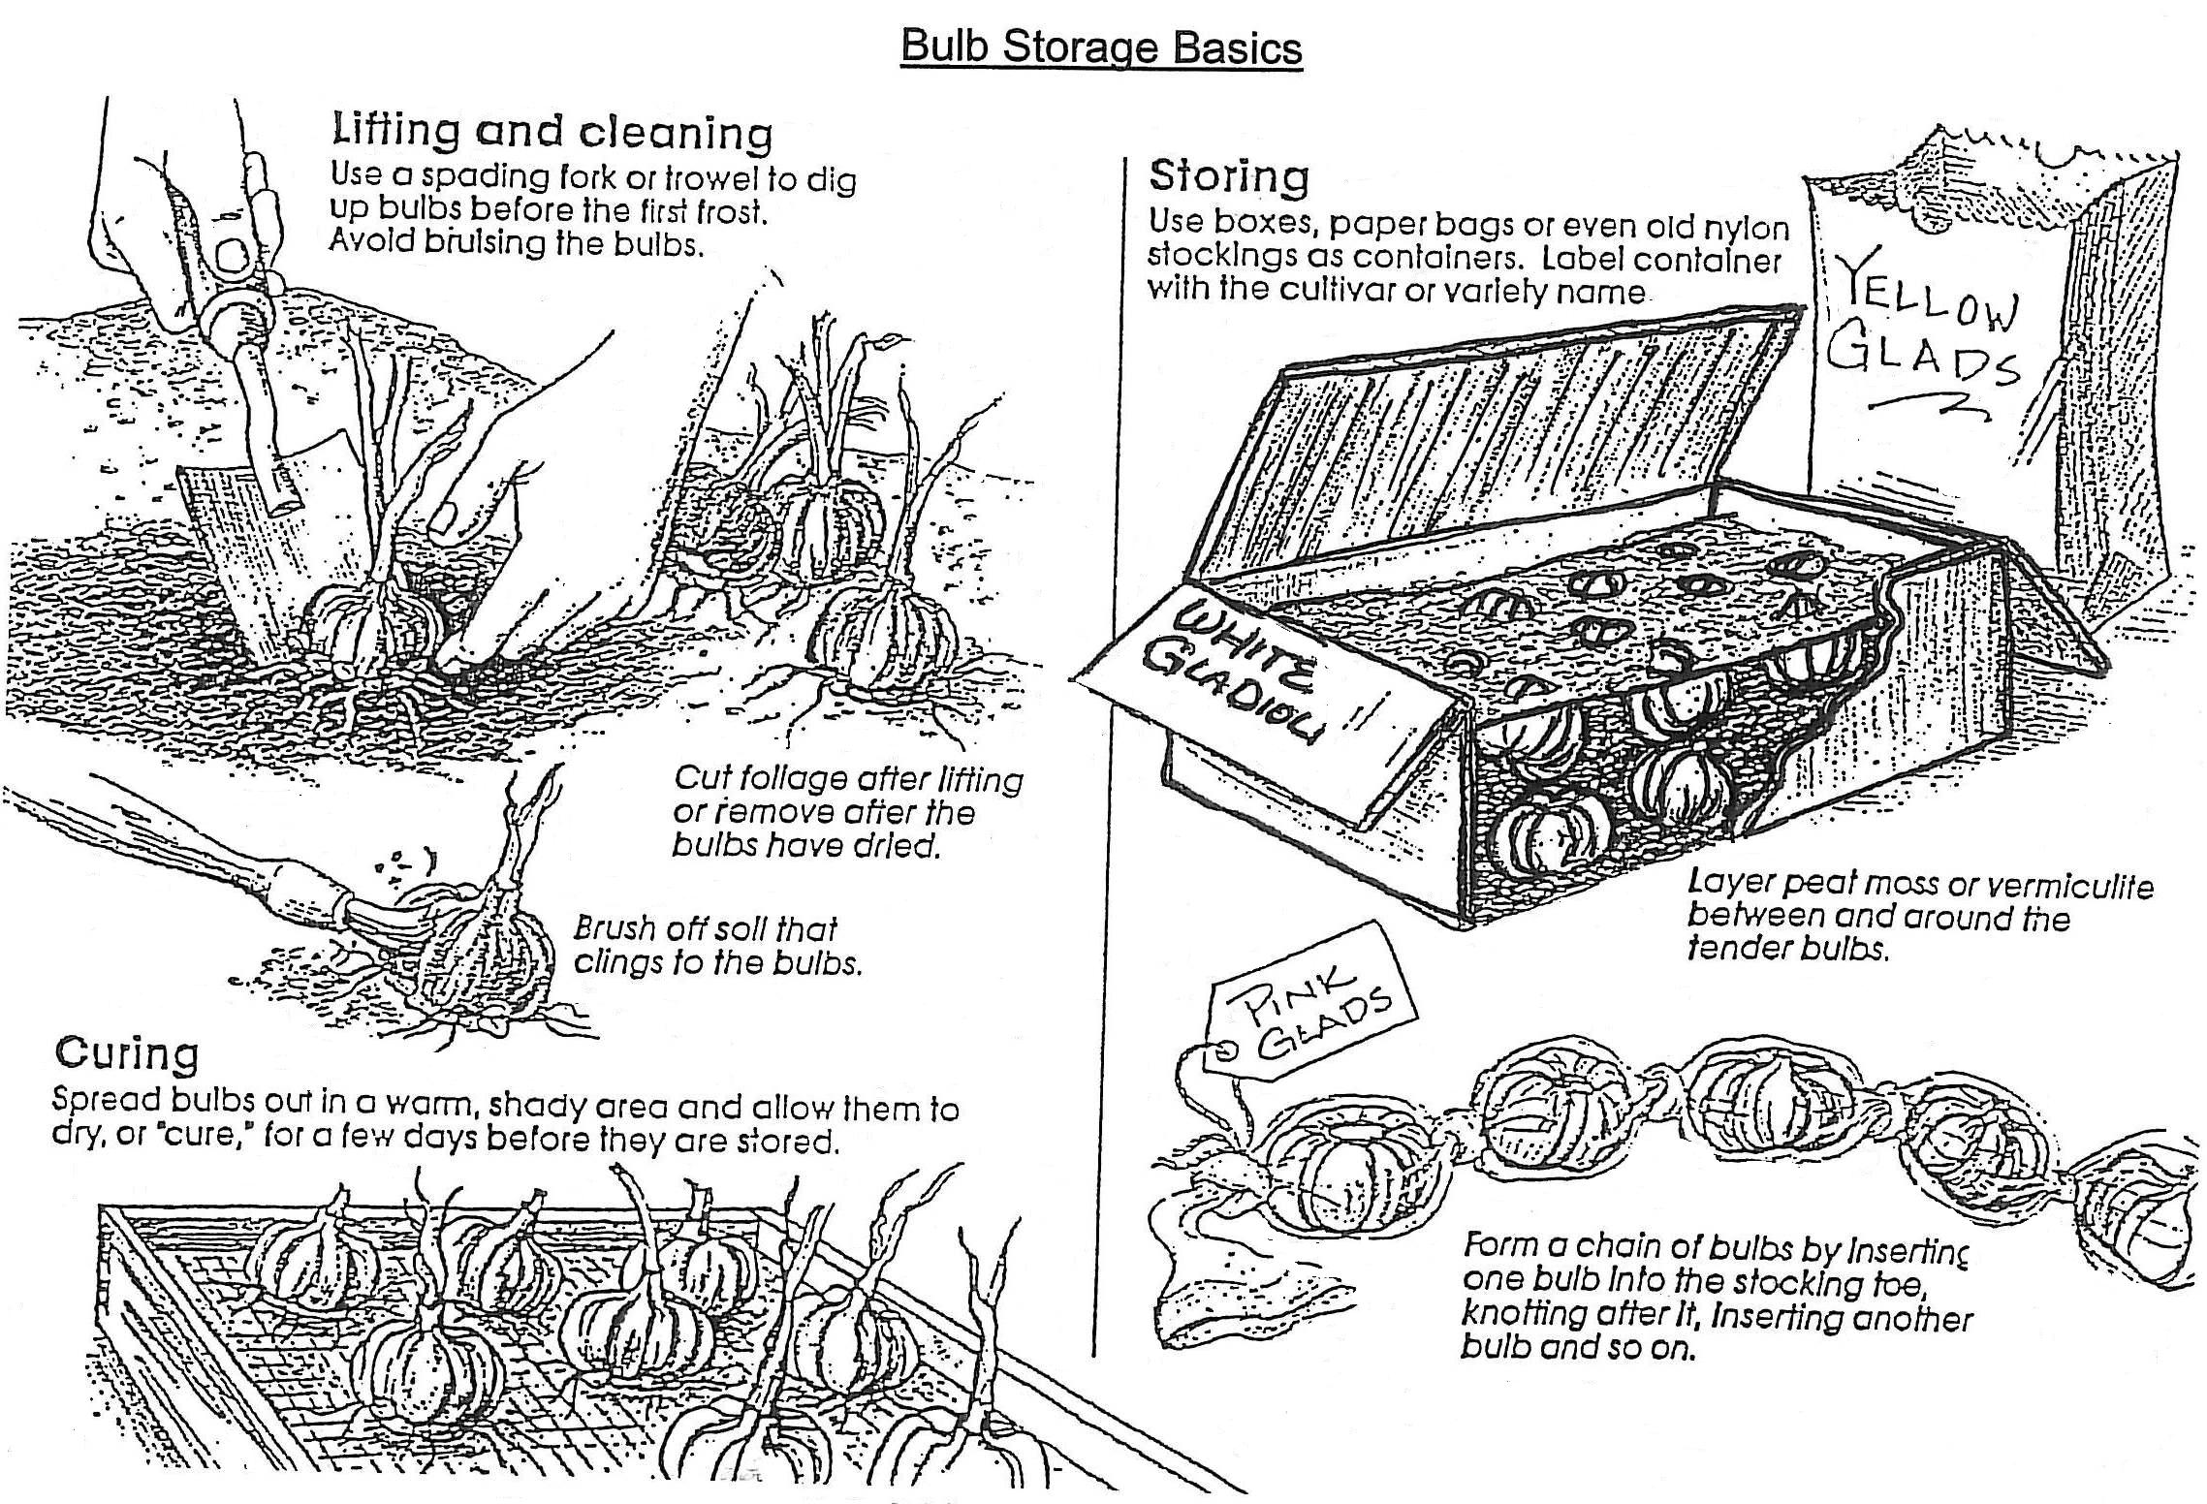
Check frequently during the winter to be sure the medium is not dry. You may have to put a few drops of water in the medium to keep the bulbs from drying out.

