

NURSERY, GARDEN CENTER, GREENHOUSE & PATIO
5150 Garrison St. Arvada, CO 80002 303-424-7979
www.echters.com

HERB BLOOM TIME

Early to late spring: violets

Late spring to early summer: sweet cicely, all flags, pyrethrum, rosemary, Sweet woodruff

Early to mid summer: bedstraw, borage, chamomile, dittany of crete, feverfew, Foxglove, germander, heliotrope, lavender, marjoram, Nasturtium, rue, clary sage, valerian, yarrow

Mid summer to autumn: bergamot, calendula, coneflower, autumn crocus (saffron), fennel, hyssop, pineapple sage, tansy

HERBS WITH COLORFUL FLOWERS

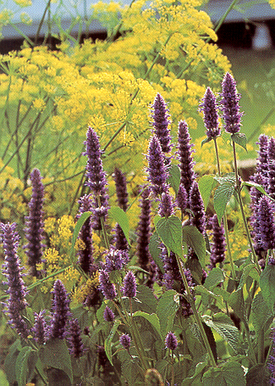
Red: bergamot, pineapple & baby sage
Purple-rose: germander, pyrethrum, valerian
Pink: dittany of crete, hyssop, chives
Orange: calendula, nasturtium, tansy
Yellow: nasturium, rue, yellow flag, yellow bedstraw
Purple: heliotrope, coneflower
Blue: borage, blue flag, fennel, hyssop, lavender, rosemary, violets
White: feverfew, pyrethrum, white bedstraw, white flag

(ALMOST) EVERGREEN HERBS

Burnet, chamomile, horehound, hyssop, rue, sage, gray santolina, winter savory, southernwood, caraway, thyme, common thyme
SALAD HERBS

Anise - leaves
Lemon balm - leaves
Basil - leaves
Borage - leaves, flowers
Burnet - leaves
Calendula - flower petals
Caraway - leaves
Chervil - leaves
Chives - leaves
Dill - leaves, flowering umbels
Fennel - leaves, flowering umbels

Lovage - leaves
Sweet marjoram - leaves
Nasturtium - leaves, petals, pickled seeds
Rose - petals
Summer savory - leaves
Sorrel - leaves
Tarragon - leaves
Sweet violets - flower petals
Watercress - leaves

TEA HERBS

Angelica Anise (seeds)
Lemon balm Bergamot
Caraway (seeds) Catmint
Catnip Chamomile
Costmary Dill (seeds)
Fennel (seeds) Feverfew
Horehound Lovage
Sweet marjoram Mints
Pennyroyals Rosemary (green sprigs)
Saffron (stigmas) Common sage
Thyme - lemon, common Lemon verbena
Wintergreen Yarrow

HERBS FOR DRY PLACES

Alkanet Bedstraw
Borage Burnet
German/roman chamomile Chives
Dittany of crete Fennel
Feverfew Germander
Lavender American pennyroyal
Perilla Rosemary
Sage Santolina
Winter savory Soapwort
Southernwood Thyme
Wormwood Yarrow

HERBS FOR MOIST PLACES

Angelica Bergamot
Sweet cicely Blue, sweet & yellow flag
Lovage Mint
Parsley English pennyroyal
Valerian Watercress (will adapt easily to ponds)

PLEASE NOTE: even drought tolerant herbs must be kept watered until they are established.

Most herbs prefer a sunny location. Indoors, a sunny windowsill is a must. Outdoors, there are a few herbs that can tolerate partial sun. Please keep in mind that less sun may result in ‘stretched’ plants in some cases and slightly lower water requirements.

HERBS THAT TOLERATE PARTIAL SUN

Angelica Valerian
Lemon balm Violets
Chervil Wintergreen
Comfrey Sweet woodruff
Costmary French tarragon
Mints Parsley
English pennyroyal

THE SHORT AND TALL OF IT
HERB HEIGHTS

GROUND COVER:
SUN: roman chamomile, thyme, caraway

SHADE: wintergreen

PART SHADE: sweet woodruff, common violet

SHORT EDGINGS:
Sweet basil, chives, germander, parsley, pennyroyal, winter savory, common thyme, sweet woodruff.

MEDIUM EDGINGS:
Most basil, feverfew, germander, hyssop, english lavender, rosemary, rue, common sage, santolina, southernwood

NOTE: hyssop, rosemary, rue and southernwood may be clipped like a box hedge but hyssop and rue will not flower if kept clipped.

TALL:
Angelica - 5’
Sweet bay - 3-4’ (bay laurel can get 10’ in pots)
Sweet fennel - 3-4’
Lovage - 5’
Clary sage - 3-4’
Tansy - 3-4’
Wormwood - 3-4’
FRAGRANT HERBS

GROUND COVER/LOW: johnny jump-ups, english pennyroyal, thymes, violets, sweet woodruff

MEDIUM LOW: dwarf basil, chamomiles, stoechas lavender, sweet marjoram, nasturtium, american pennyroyal, winter savory.

MEDIUM HIGH: sweet basils, burnet, feverfew, heliotrope, hyssop, english lavender, spike lavender, mints, scented geraniums, rue, sage, tarragon, yarrow.

MEDIUM TALL: lemon balm, bergamot, sweet cicely, costmary, dill, sweet flag, southernwood.

TALL: angelica, sweet bay, fennel, lovage, pineapple sage, tansy, valerian, wormwood.

COMPANION PLANTING HERBS

Basil - any vegetable
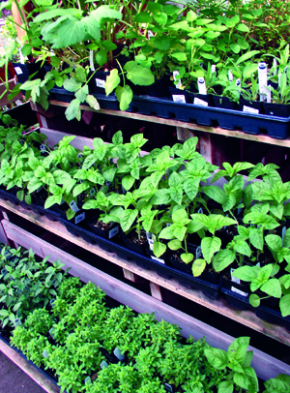
Borage - squash, tomatoes
Chamomile - cabbage
chives - carrots / avoid beans & peas
Dill - cabbage, cucumber, lettuce, onions / avoid tomatoes & carrots
Fennel - avoid vegetables
Garlic - beans
Geraniums - any vegetable except cucumbers
Hyssop - cole crops
Mints - cole crops, radishes, tomatoes
Oregano - cole crops
Parsley - corn, asparagus, carrots, tomatoes
Rosemary - cole crops, beans, carrots
Sage - any vegetable except cucumbers
Summer savory - tomatoes, beans, onions
Winter savory - any vegetable
Tansy - cole crops
Thyme - any vegetable
Valerian - any vegetable

REMEMBER: some herbs are insect repellants, some attract insects away from vegetables and some are symbiotic (other plants grow better when they are nearby). Some herbs can even inhibit the growth of certain vegetables.

HINTS:
- Grasshoppers love tansy. Tansy is very invasive!
- Cats dislike rue (it doesn’t bother dogs).
- Yarrow is very symbiotic and serves to increase most vegetables resistance to adverse conditions.
- Valerian may attract field mice and rats from nearby open fields or empty lots.

