

NURSERY, GARDEN CENTER, GREENHOUSE & PATIO
5150 Garrison St. Arvada, CO 80002 303-424-7979
www.echters.com

HIBISCUS CARE SHEET
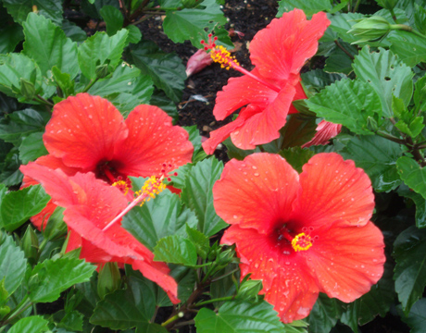
This tropical plant makes a wonderful indoor plant for a very sunny area. It features glossy dark green foliage and one of the showiest blooms available. Blossoms range from 4-8 inches wide. Flowers usually last only a day or two, but the plant flowers profusely from spring to fall.

Hibiscus may be placed outdoors during the warm summer months if watering is regularly monitored and pests are controlled. This plant is particularly susceptible to aphids, white fly, and spider mites. Be certain to check for these pests before bringing it indoors for the winter months.

Hibiscus require as much light as possible but hot sun can burn the foliage. Keep the soil moist at all times, but do not let the pot stand in water. Hibiscus are dependent on good drainage. Standing water will promote root damage. Ideal growing temperatures are 65-85 degrees Fahrenheit. This plant is not hardy in our climate and should be grown indoors year round or brought indoors as night temperatures approach 58-60 degrees Fahrenheit. At this temperature the plant will begin to go dormant.

Fertilize twice monthly from April to September. Jack’s Classic Houseplant Special will be great to support both flowering and general growth (15-30-15). Decrease fertilization to once per month during winter. It is best to repot yearly in the early spring. Use a light weight soil that will drain well, like Echter’s Indoor Potting Mix.

To keep plants growing vigorously and to retain overall shape, prune out about 1/3 of the old wood in early spring.

COMMON PROBLEMS

Bud drop - This can be caused by sudden temperature change or underfeeding. It is most commonly the result of under watering.

Curling leaves - The air is too dry. Attempt to increase humidity by frequent misting or a pebble tray.

Leaf loss - This is usually caused by under watering. It can also be the result of cold draughts, aphids and Spider Mites - Frequent spraying with water will help to eliminate many of the pests. You may need to use insecticidal soap to control these pests. In severe cases bring a sample of the foliage in for recommendations.

