

NURSERY, GARDEN CENTER, GREENHOUSE & PATIO
5150 Garrison St. Arvada, CO 80002 303-424-7979
www.echters.com

Holly
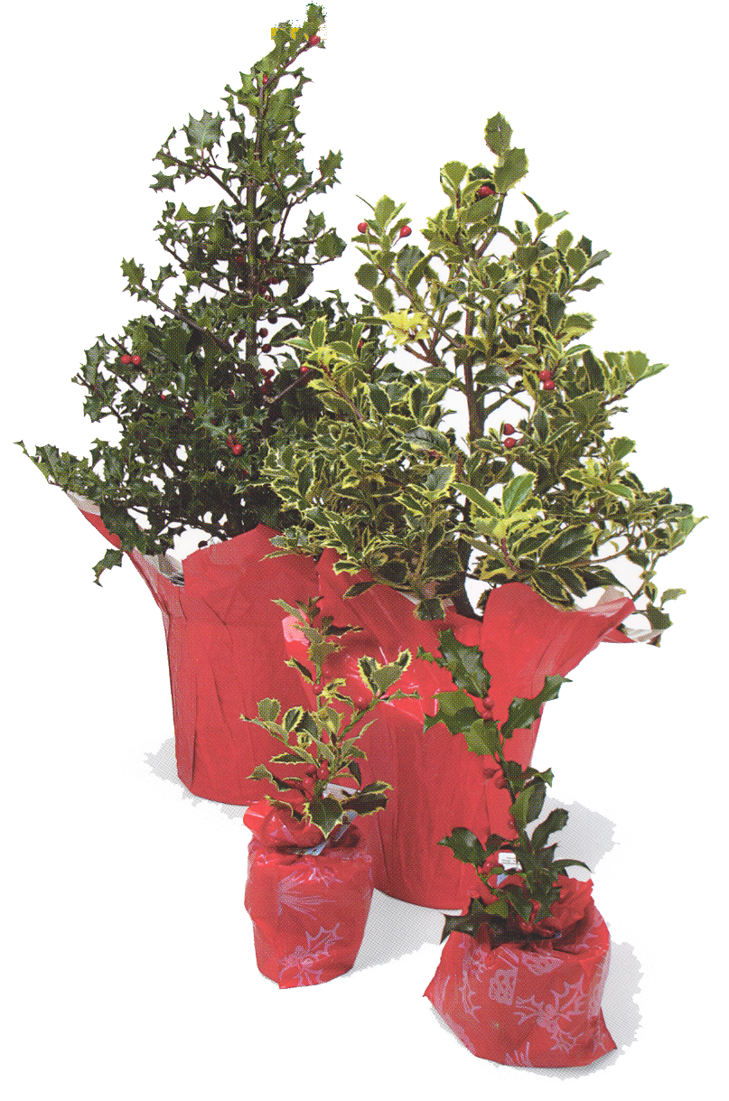

This evergreen bonsai can be kept indoors in a well lighted area. It can also be kept outdoors in partial shade or full sun during the spring, summer and fall. Protect from frost. It prefers outdoors for compact growth.

WATER: It is best to feel the soil surface daily. If the soil feels cool and moist, do not water. If the soil feels dry or room temperature, soak your bonsai in a bucket or bowl of water. The level of the water should be a half inch or so higher than the top of the bonsai pot. Wait until the pot stops bubbling and slowly bring the pot out of the water to drain your bonsai.

PESTS: Holly can be susceptible to mealy bugs. Gently wash off leaves when watering to help prevent an infestation. If you do notice some mealy, we recommend that you use Safer Insecticial Spray. Follow the instructions for use on the back of the bottle.

FERTILIZE: Every two weeks during the growing season with either Jack’s Classic Houseplant or Jack’s Classic Acid Special. Dilute to half strength. Do not fertilize during the winter months.

TRAINING: You will need to trim and pinch your holly as needed to maintain and develop a bonsai or tree shape. If your tree has wire on it be sure to remove it in six months or, when it starts to show signs of cutting into the bark.

BONSAI: Is a wonderful living art form. But, your Bonsai is also somewhat delicate and does require consistent care. Be sure to check it every day so that you are able to properly provide for its needs. Even one drying out is enough to seriously injure your Bonsai. With the proper care your Bonsai will continue to give you pleasure for many years to come.

