
NURSERY, GARDEN CENTER, GREENHOUSE & PATIO
5150 Garrison St. Arvada, CO 80002 303-424-7979
www.echters.com

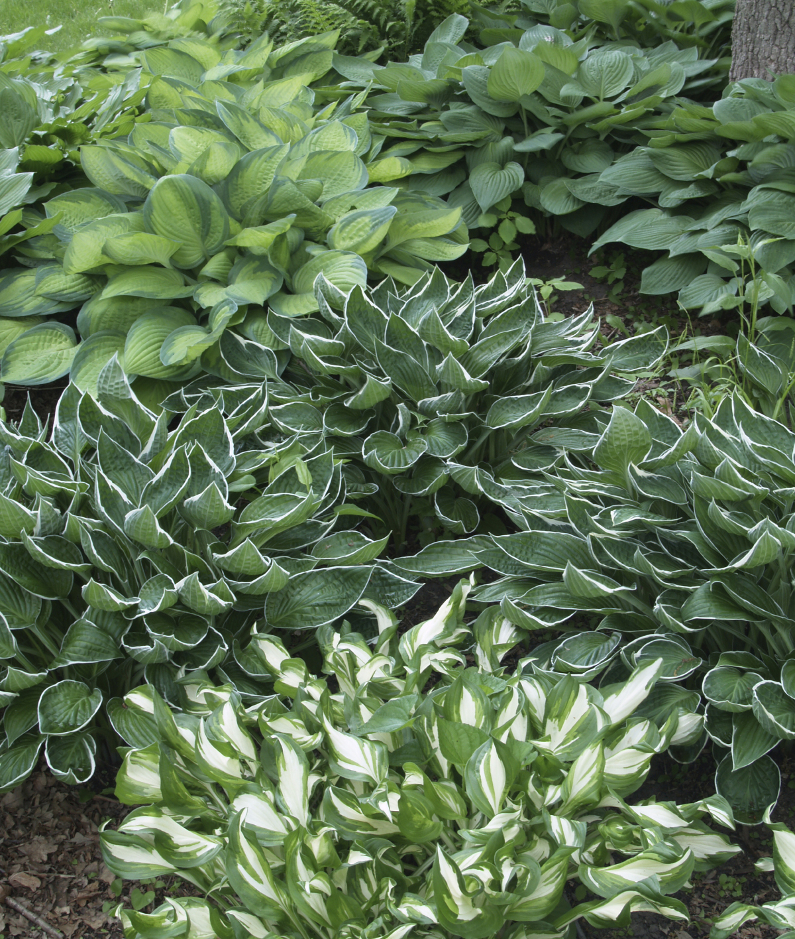
Hosta

General - Hostas are very versatile plants, hardy to USDA Zone 2. Because of the wide variety of sizes, shapes and foliage colors they are wonderful companion plants providing bold contrast in the garden. The summer blooming flowers are a delightful bonus and are frequently very fragrant.

Culture - Hostas perform best in deeply dug soil (l4”-l8”) amended with sphagnum peat moss, compost and super phosphate. Mulching is always a good idea since Hostas prefer evenly moist (NOT WET) soil conditions. In Colorado it is best to keep them out of the hottest rays of the sun. Shaded areas are best, however Hostas will also grow well in filtered light or in areas with morning or late afternoon sun.

Planting - Check the label to determine the height and spacing so that plants will be placed appropriately. Because of the considerable variation in size you will find Hostas useful as edging, ground cover, background plants or as specimen plants providing a focal point in the garden. Some of the smaller, slower growing varieties are suitable for planting in the rock garden.

Division - Clumps may be divided in the spring if increase in stock is desired, however, Hostas have no need for regular division. Clumps may remain in place for many years, growing larger and more impressive each year. Initial planning and spacing will provide Hostas the space to grow big and beautiful.

Insects - Hostas are tough but not problem free. Slugs are the primary culprits for damage
to Hosta. Slug baits or slug killers may be used for control. Diatomaceous Earth, a talc-like powder may be used around plant as well. Small cans of beer placed nearby will also attract slugs away from the plants. Remember, that although useful for moisture retention, mulching can contribute to the creation of a slug habitat. Be sure to regularly monitor the area and be prepared to control.

Hail can also be very detrimental to the appearance of hostas. Their large, tender leaves are very vulnerable to the shredding of hail. After hail damage, remove torn foliage and wait for new growth to appear.

