

NURSERY, GARDEN CENTER, GREENHOUSE & PATIO
5150 Garrison St. Arvada, CO 80002 303-424-7979
www.echters.com

Ideas for Wreath Decorations

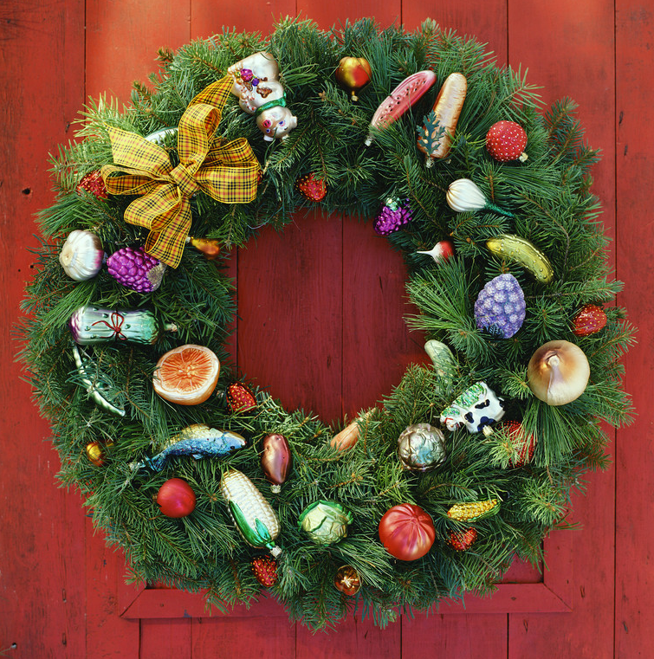
Ornaments, bells, pine cones, Holly sprigs, berries, bows, ribbons and candy canes are common decorations on Christmas wreaths; however, wreaths are not just for Christmas. You can create a wreath for any occasion, and decorate it with items that a friend or a family member likes. Following are some ideas you may find helpful:

Fruit: Small apples, oranges, cranberries, grapes, artichokes, or the miniature pumpkin and gourds you can find in the fall.

Flowers: Dried, silk or plastic flowers, vines or leaves and berries. Sometimes you can even gather these items from your own garden at home.

Herbs/Spices: Cinnamon sticks, Rosemary, Yarrow or Eucalyptus branches.

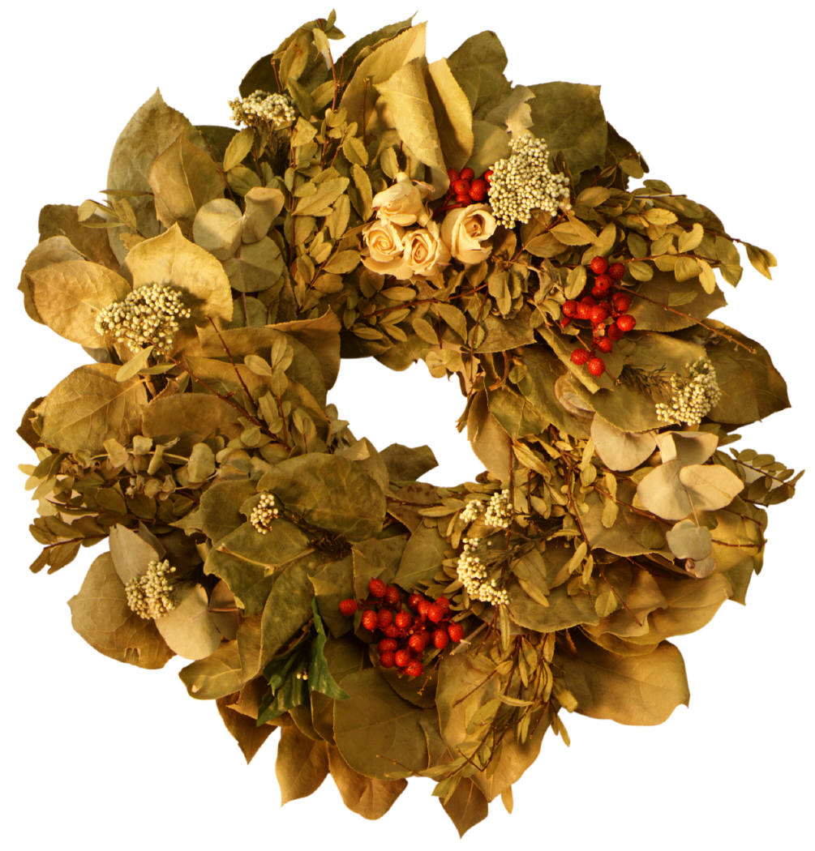
Dolls, beads, paper or wooden shapes you make for yourself, small or stuffed toys, seashells, Matchbox cars, ribbons, pictures of you and your family/friends/pets or any other miniature collectibles are only a few of the things you can use. Make a wreath with Tootsie Roll Pops if you want!

Don’t be afraid to use your imagination!

Happy Holidays from Echter’s

(Turn over to recipe for Baker’s Clay)
Recipe for Baker’s Clay

Ingredients you will need:

4 cups of flour
1 cup of salt
1 ¼ to ½ cups of water
Optional: Food coloring

Mix all ingredients together. (Add food coloring to mixture – one drop at a time – if you wish to have colored clay).

Knead until smooth.

Preheat oven to 300 degrees Fahrenheit.

Roll out clay on way paper to desired thickness.

Use cookie cutter to cut out desired shapes.

For shapes that will be used as ornaments, be sure to poke a hole all the way through the clay BEFORE you put them in the oven to bake!

It is also a good idea to make small indentations with a toothpick or pencil for any eyes, buttons, etc., that may be glued on later.

Place shapes on cookie sheet and bake until set and light golden in color (approx. 30-45 minutes).

Allow the shapes to cool thoroughly before painting or decorating.

