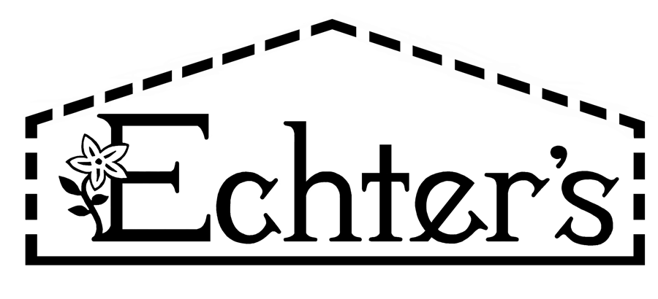

NURSERY, GARDEN CENTER, GREENHOUSE & PATIO
5150 Garrison St. Arvada, CO 80002 303-424-7979
www.echters.com

Insecticides Index

Synthetically derived:

- Carbamates

  - Carbaryl – Sevin (RTS, Granules), Bonide Fruit Tree Spray

- Pyrethroids

  - β-Cyfluthrin - Bayer Rose + Flower Insect Killer (aerosol)

  - Bifenthrin- FL Broad Spectrum Insecticide

  - Cypermethrin – GT Home Insect Fogger, GT Wasp + Hornet Killers, GT Roach Ant + Spider Killer

  - Deltamethrin - Bonide Household Insect Control

  - Gamma-cyhalothrin – Triazicide (RTS, Granules)

  - Lambda-cyhalothrin – Bonide Rose Shield, Bonide Fruit Tree + Plant Guard

  - Prallethrin – GT Wasp + Hornet Killers

  - Permethrin- Bonide Eight (RTS, Conc, Dust), FL Indoor/Outdoor, Bonide Ant Killer, Bonide Spider + Gorund Bee Killer, Summit Mosquito + Gnat Barrier

  - Tau-fluvalinate – Bayer 3n1 Insect Diesaes + Mite Control (RTU, RTS)

- Neonicotinoids

  - Clothianidin – Bayer Tree + Shrub Protect + Feed, Bayer All in 1 Rose + Flower

  - Imidacloprid – HY Systemic Insect Granules, Bonide Systemic Insect Granules, Bonide Systemic Houseplant Insect Control, FL Tree + Shrub Drench, HY Grub Free Zone II, Bayer Rose + Flower 2n1, Bayer Tree + Shrub Protect + Feed, Bayer All in 1 Rose + Flower

  - Malathion – Bonide Fruit Tree Spray

  - Thiamethoxam – Bonide Rose Shield

- Organophosphates

  - Acephate- Bonide Systemic Insect Control (Conc)

  - Trichlorfon – Bayer Grub Killer Plus

Naturally derived:

- Azadirachtin - Azamax
- Bacillus Thuringiensis (BT) Israelensis Strain - Mosquito Dunks, Mosquito Bits
- Bacillus Thuringiensis (BT) Kurstaki Strain – Dipel Dust, NG Caterpillar Killer w/ BT
- Capsaicin – Bonide Hot Pepper Wax
- Diatomaceous Earth – NG or Bonide
- Insecticidal Soaps – Safer, Bonide, NG Spinosad Soap
- Iron Phosphate – Espoma Slug + Snail Control, Bonide Bug + Slug Killer
- Mineral Oil – Bonide All Seasons Oil
- Neem – Bonide Neem Oil, Bonide Bon-Neem, Bonide Rose RX, FL Triple Action, GS Fungicide 3

- Nosema locustae – Nolo Bait
- Pyrethrins – GS Houseplant + Garden Insect Killer, Bonide Garden Dust, Bonide Tomato + Vegetable, FL Triple Action, Bonide Bon-Neem, Safer Wasp + Hornet Killer

- Spinosad – Bonide Capt Jack’s Deadbug Brew, Bonide Bug + Slug Killer, NG Spinosad Soap

