

NURSERY, GARDEN CENTER, GREEN HOUSE & PATIO
5150 Garrison St .Arvada, CO 80002 303-424-7979
www.echters.com

Installing A Yard Pond is Simpler Than You Think!
Do-It-Yourself Landscaping – Makes Your Yard a Living Showplace

Below are six illustrated steps showing how you or your customers can simply, quickly and easily install a Tetra yard pond. After you have determined the dimensions of your pond and selected the liner along with the location on your property, the work, or if you will, the fun begins! For further information, just drop us a note or give us a call. If you aren’t in the yard pond business now, you are missing truly additive business.

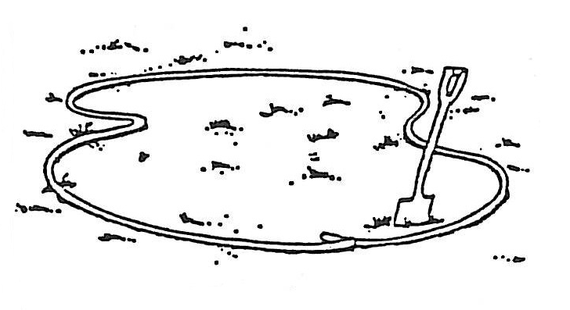
- Select a location on your property where the ground is fairly even and the pond will get a minimum of 6 hours of sunlight (no more if Koi are to be kept) per day. It is best not to place the pond directly under trees, since falling leaves can foul the water and the tree roots will make digging difficult. Freeform your pond in any design you choose, using a heavy garden hose or a heavy rope to lay out your design.

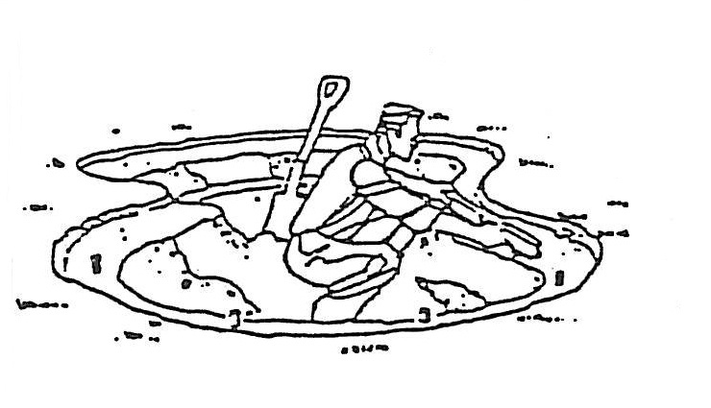
- Using a level, dig 2 or 3 tiers in your pond. Fish benefit from a shallow area (feeding on insects), and a deep area provides them security. The tiers can be used to place plants such as lilies. Depending on your climate, your pond at the deep area should be anywhere from 24” to 40” deep. The shallow area can be 4” to 12” deep.

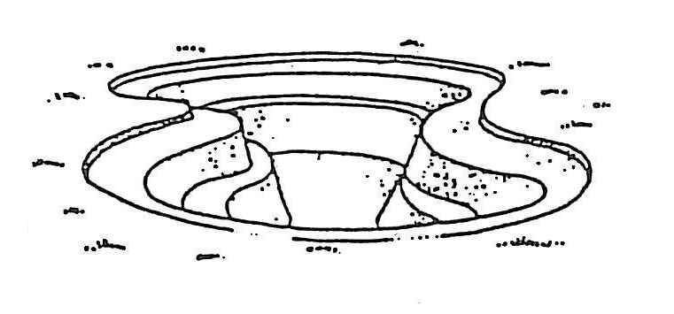
- When constructing your pond, you should line the ground with sand, carpet padding, or even old newspapers. This will protect your pond liner against sharp, protruding objects (roots or rocks).

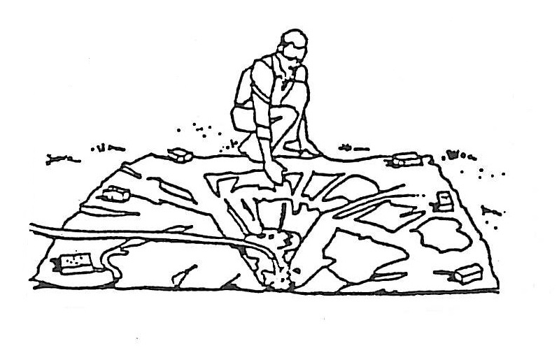

- Place your liner loosely over the pond, holding it in place with bricks or other heavy objects. Fill the pond with water. Your liner will conform to the design of the pond on the top and below the surface as it is weighted by the water.

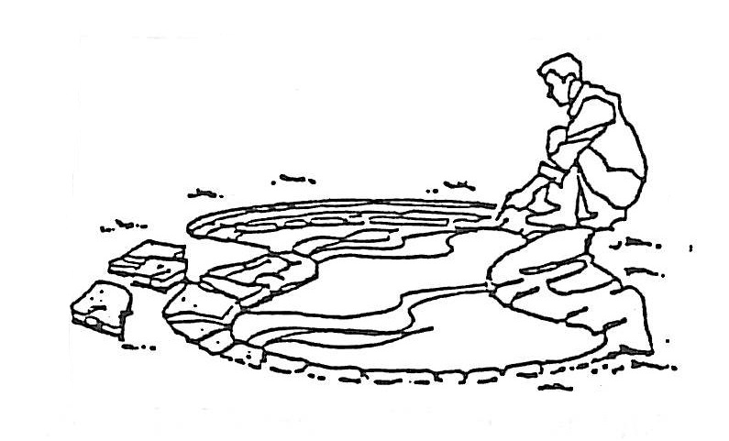

5. To create a professional look, build a rock border around your pond, allowing the rocks to overlap the water by 1” to 2”. The excess liner can be tucked under the border or trimmed. Be sure to allow excess, if you trim, since your pond will settle. Flat rocks and/or washed sand make a decorative interior for your pond.

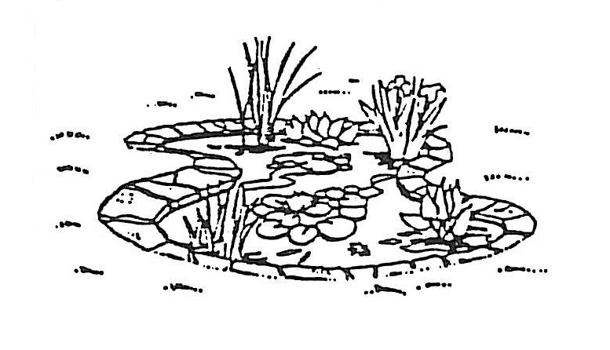
- Install the Tetra Brilliant G-Filter and tread your pond water with Tetra Aqua-Safe Pond Formula. Add plants so that one-half the water surface is covered; be sure to fertilize with Tetra FloraFin. Wait several days and add a few fish. Wait an additional 30 days to add the balance of your fish. This will ensure your pond and filter are biologically ready to support aquatic life. Rinse your Tetra foam filter regularly (10-14 days) to ensure adequate airflow.

Feed your fist Tetra Pond Food or Tetra Koi Food. Fish are best fed in the morning, only the amount they can consume in a few minutes.

In the Winter

If you live in an area with harsh winters, remove the Tetra Brilliant G-Filter at first frost. Unless the water will freeze complete to its lowest depth, pool and pond fish (large Common and Comet goldfish) and plants can remain year-round. The metabolism of these fish directly relates to water temperature. During the winter they will be dormant, and even if the ice melts, never feed them, since the food will only contaminate the water. At the onset of spring (as soon as the water temperature reaches 50 F) reinstall your filter and begin feeding your fish. Your pond is simple to construct, it’s easy to maintain, and it will provide years and years of trouble-free enjoyment.

