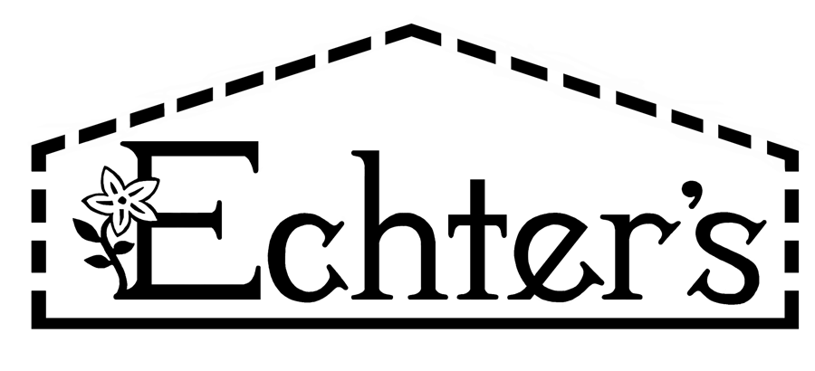

NURSERY, GARDEN CENTER, GREENHOUSE & PATIO
5150 Garrison St. Arvada, CO 80002 303-424-7979
www.echters.com

Japanese Maples

How to grow them in the Denver Metro area
Zone 4-5

Yes, these graceful and delicate looking beauties will grow successfully in your garden if the requirements listed below are met.

- Exposure Eastern exposure is best. Morning sun only with afternoon shade or filtered sun all day. Leaves will burn in too much sun.

- Location Site should be well protected from excessive winds. A mature neighborhood with established shade trees is preferable to a new (treeless) area. Fencing or other artificial windbreaks are helpful.

- Soil Rich organic soil is best. Blend 50% top soil with 50% compost or peat moss. Site must be well drained. Mulch up to 2” depth to help maintain even moisture supply.

- Watering Must have ability to provide ample water to the plant in every season. Winter watering is essential in our dry climate. Maintain even moisture supply. Never allow it to dry out completely.

- Container
Growing Follow standard container culture. Must move plants to cool protected indoor/outdoor location for winter, such as a garage, uninsulated entryway or sunroom, and allow to go dormant. Reduce moisture, but never allow to completely dry out.

