

NURSERY, GARDEN CENTER, GREENHOUSE & PATIO
5150 Garrison St Arvada, CO 80002 303-424-7979
www.echters.com

Layers of Bulbs for Loads of Blooms – in Pots

Imagine a container of beautiful flowers that blooms from January through April. It’s easy with a pot full of bulbs! Here’s how to create one.

Step 1.
Select a container of your choice (terra-cotta or plastic) at least 8 inches deep and 12 to 14 inches in diameter. Make sure the container has at least one drainage hole in the bottom. Cover the drainage hole with a piece of broken flowerpot or screen to prevent the soil from washing through. Add about 3 inches of good quality potting soil, such as Echter’s Hanging Basket/Planter Box Mix, to the container. Now you’re ready to plant!

Step 2.
The secret to a successful blooming container is to plant the bulbs close together and in layers. On top of the soil in the pot, arrange 5 or 6 tulips of your choice. Also arrange 10 to 12 bulbs of daffodils (also called narcissus). Now cover the tulip and daffodil bulbs with a layer of soil.
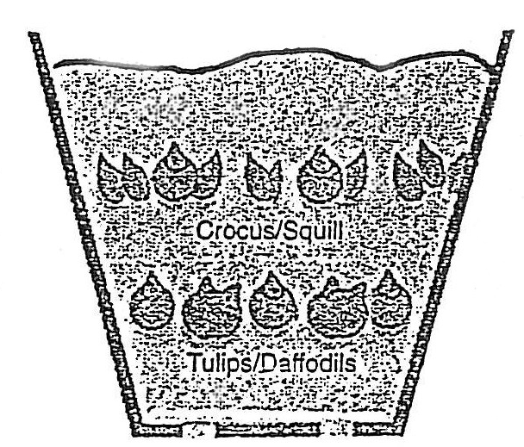
Step 3.
On top of the soil, arrange 12 to 15 bulbs of giant crocus bulbs of Siberian squill (Scilla siberica) or striped squill (Puschkinia libanotica). Cover this second layer of bulbs with soil and water thoroughly. Place the container of bulbs in an unheated garage where bulbs will be cold but will not freeze. Don’t forget to water the bulbs from time to time.

Step 4.
Sit back and relax! Beginning in January you will see the tender green shoots of bulbs popping through the soil. At that time, move the container near a sunny window. By February, the crocus will be in bloom. The daffodils will emerge through these tiny flowers and begin to bloom in March, followed by the tulips and squill in April.

