
NURSERY, GARDEN CENTER, GREENHOUSE & PATIO
5150 Garrison St. Arvada, CO 80002 303-424-7979
www.echters.com

Live Christmas Tree Care
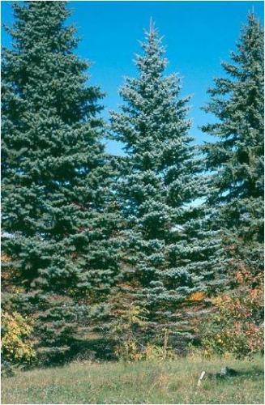
- Dig a hole for the permanent tree location now while the soil is still soft enough to dig. The hole should be the same depth as the tree ball and at least twelve inches in diameter wider.

- Cover the hole, for safety, with planks or plywood.

- Cover the soil from the hole with a loose mulch such as wood chips, leaf mold or compost and polyethylene plastic. This will help prevent the soil from freezing and also from getting too wet. You may also wish to take the soil to be used for backfill and place it in containers and store it in an area where it will not freeze.

- Before the tree is to be taken indoors, keep it in a cool, shaded location. Water the soil ball at least once each week but not the day the tree is to be taken indoors. On burlapped trees, keep the burlap moist but avoid getting the ball too wet.

- The tree should be located indoors in the coolest part of the house, away from heaters or return air draft vents. It should also be far enough away from a window to avoid direct sun exposure.

- Plan to keep the tree indoors no more than one week. Survival chances are reduced the longer a tree is left indoors.

- When the tree is ready to be moved out return it to a cool (40-60 degrees F) shaded location such as an attached unheated garage. Water the soil ball weekly and allow it to remain for at least two weeks.

- After the two-week period, the tree may be planted out if outdoor temperatures are not below 25 degrees F. Otherwise leave it in the protected location and water weekly.

- When planting, remove any container made of plastic, metal or paper fiber. On wooden containers, remove bottom, place in hole and then remove sides. On burlapped trees, be sure to cut the strings from around the base. Replace the soil and water in thoroughly.

- Apply a mulch four inches deep on top of the soil in the vicinity of the planted area. Water the tree if dry weather persists.

One of the dangers involved in a live Christmas tree is the number of times it has to be handled before it finally reaches the permanent site. Every time it is moved some disturbance occurs to the root system. To reduce damage, always lift by the soil ball, not by the top. Do not allow the tree ball to drop onto a hard surface even if it is in a container.

