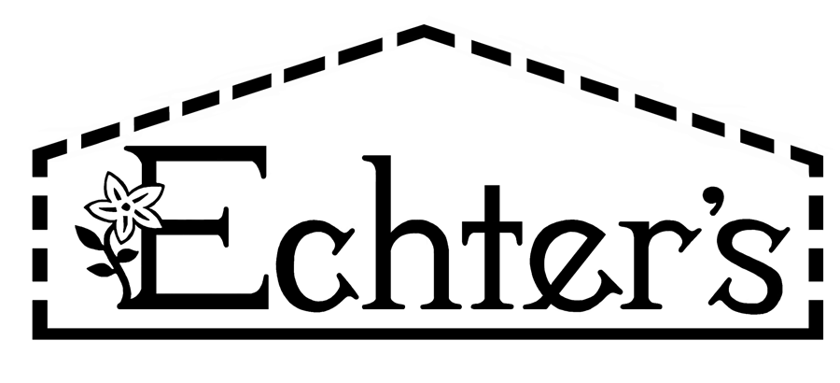

NURSERY, GARDEN CENTER, GREENHOUSE & PATIO
5150 Garrison St. Arvada, CO 80002 303-424-7979
www.echters.com

Mountain Grass Mix

40% Tetragold Annual Forage Ryegrass
20% Ryegrain VNS
15% Kentucky Bluegrass
10% Potomac, Orchard grass
05% Smooth Bromegrass
05% Timothy Grass
05% Alsike Clover

Sow Rate: 6 to 7 pounds per 1,000 square feet or 30 pounds per acre

A mixture of sod-forming and bunch-type, cool season, perennial grasses combined with a legume for a natural source of nitrogen. Used for high altitude ranges and meadows. May also be used for soil conservation and stabilization.

Mountain mix contains grasses that are deep-rooted, drought and cold tolerant. Grass blades vary from medium to wide-bladed with a medium-green color.

Grows in a variety of soil types with or without irrigation. Non-irrigated stands should have soil preparation prior to planting the seed. Seed must be covered to germinate. Needs even and consistent moisture to germinate and establish.

Throwing seed on top of snow is not recommended.

Wildlife will find Mountain mix palatable and nutritious. If mowed, adjust mower blade height to 4 inches. May be combined with tall growing wildflowers for a meadow appearance.

