

NURSERY, GARDEN CENTER, GREENHOUSE & PATIO
5150 Garrison St. Arvada, CO 80002 303-424-7979
www.echters.com

NORFOLK ISLAND PINE CARE SHEET
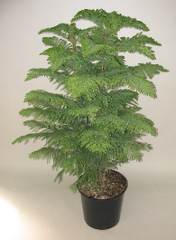
Symmetrical tiers of branches with needle-like leaves. Trees range in size from those small enough to be displayed in a terrarium to very tall specimens placed in entryways or large rooms.

This is an easy-to-grow conifer. Norfolks grow slowly, so be patient if you want it to grow into a large specimen. Place it in a brightly lit, cool location. Keep the soil moist and protect it from hot, dry air. The plant rests during the winter. With proper care it can eventually reach 10 to 15 feet tall indoors.

TEMPERATURE: 55 - 65 degrees Fahrenheit days and nights. Cooler in winter.

LIGHT: Bright indirect light. Protect from direct sun in summer.

WATER: Water thoroughly, but let soil become moderately dry between waterings.

SOIL MIX: Echter’s Indoor Potting Mix.

REPOTTING: Repot every 3-4 years. Keep it pot bound to restrict growth.

PEST AND PROBLEMS: Leaf drop and loss of lower branches is caused by hot, dry air or insufficient moisture in soil. Water logging may also be the culprit. Dropping of older leaves and lower branches is natural.

