

NURSERY, GARDEN CENTER, GREENHOUSE & PATIO
5150 Garrison St. Arvada, CO 80002 303-424-7979
www.echters.com

Planting Instructions and Care
For Container Grown and Balled & Burlapped
Trees & Shrubs

The first step to ensure successful planting of trees and shrubs is matching the right plant to an appropriate site. The mature size and the cultural requirements of plants vary significantly. This should be considered carefully prior to purchasing since trees and shrubs represent a significant and permanent investment in the home landscape. Consider soil conditions, wind exposure, sunlight requirements and moisture needs. Your nursery salesperson can assist you in making selections appropriate to your specific site.

- To minimize transplant shock, plant in the cool of the morning, evening, or on a cloudy day. This is especially important in the hot summer months.

- Water the root ball thoroughly, and allow to drain before planting.

- Dig the planting hole with 45º sloping sides at least three times wider at the top of the hole than the width of the root ball, but NO DEEPER. In heavy clay soils, dig a shallower hole so that the root ball will sit 2” above grade when placed in the hole. Above grade planting is most important for all evergreens, due to their fibrous and shallow root systems, which require more oxygen.
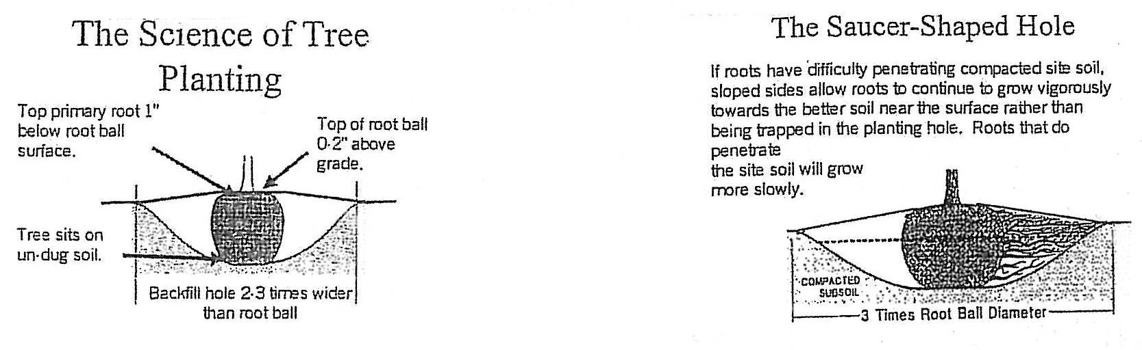

- It is important to set the root ball on firm ground. Organic material or gravel placed in the bottom of the hole will not improve drainage. Instead, those additions can trap water around the root ball, which drives out oxygen and contributes to root rot.

- Set aside ½ of the soil removed that will not be put back into the hole. Thoroughly mix together 1 part Nature’s Yield Compost or Premier Sphagnum Peat Moss to 2 parts soil removed from the hole-DO NOT over amend the soil!

- The addition of organic soil amendments help to break up heavy clay soils and improve aeration. In sandy soils, organic material provides nutrients and improves moisture retention. The goal is to provide a transition from the root ball to the surrounding soil in order to maximize root development. Prepare a mixture of Fertilome Root Stimulator, following instruction on the label. Use this to mixture to water in your new plant.

- Balled and Burlapped: After the plant is placed in the hole, remove any twine from the trunk area, and cut away and remove the top 2/3 of the wire basket. BE VERY CAREFUL NOT TO DAMAGE THE ROOT BALL! At this time, pull away the burlap from the trunk area, exposing the top 2/3 of the root ball only.

Fiber Pots: Place the plant in the hole and carefully cut the side of the pot with a utility knife. Peel the pot away from the root ball. Contrary to popular belief, in Colorado soils, the fiber pots DO NOT break down if they are left on the root ball. Do not plant in the fiber pots!

Plastic Pots: Lay the pot on its side, hold the trunk or stems firmly and slide the pot away from the root ball. Place the plant in the hole.

- Never let the plant roots be exposed directly to the sun longer than it takes to back fill! With the plant in the hole, fill halfway with the backfill mixture. DO NOT TAMP. Water thoroughly with the root stimulator mixture. Fill the hole with the remaining backfill mixture and water in thoroughly. Mulch the root ball area to a depth of 4” with bark mulch. If planting in a lawn area, apply the mulch no deeper than 2”. The mulch will help to cool the roots, conserve water and reduce weeds.

- Staking: Deciduous trees over 8’ tall and evergreens over 6’ tall should be staked for the first growing season. Larger caliper evergreens may require an extra year, especially in areas of high winds. Two-inch caliper and/or 10’ tall trees will require 2 heavy-duty stakes. When attaching, remember to leave slight play in the rope between the stakes and the tree. Staking kits are available with instructions attached.

After Care

- Plants are more sensitive to water stress for the first two years after planting. The water requirements for plants vary significantly. Group plants according to their water needs. As the plant becomes established, gradually decrease the frequency of watering and increase the amount of water. Less frequent, deeper waterings promotes a deeper root system, which is more tolerant to periods of drought and heat. To check for moisture level, use a trowel to dig down 6-8”, or push a length of rebar in that far. If you can’t push the rebar in that far, you need to water.

- Factors That Affect Watering Frequency:
  - Root ball size- The smaller the root ball, the more frequently it needs to be watered.

  - Amount of rainfall- Nature may take care of some of the watering for you!

  - High temperatures- Heat can dry out the soil faster.

  - Sun and wind exposure of the planting site- Hot and reflected sun with high wind exposure will cause plants to desiccate (lose water) more quickly.

  - Soil type- Sandy and rocky soils dry out more quickly than heavy clay soils.

  - Lay of the land- Slopes allow for run-off and may dry out quickly, while swells tend to collect water and may stay wet longer. Adjust watering accordingly.

- It is not uncommon for new plants to wilt slightly during the heat of the day. This is referred to as midday wilt. This is a natural occurrence and does not always mean the plant needs water. CHECK THE SOIL FIRST. If it is moist DO NOT water. The plant will revive as the day cools off.

- Winter Watering: In the semi-arid climate of the Rocky Mountains, winter watering is essential. Moisture loss is the leading cause of plant death. Winter watering with the use of a Ross Deep Root Feeder will help to ensure the survival of both newly planted and established plants.

- Fertilizing: Usually new plants have enough fertilizer for the first growing season. The following spring and each spring thereafter, you will need to fertilize. We recommend using Ferti-lome Granular Tree & Shrub Food. This should be applied after leafing out in the spring, then watered in. Do not apply fertilizers to trees and shrubs after July.

- Tree Wrap: Tree wrap should be used in winter on newly planted deciduous trees. Wrap trees at the end of November and take off the tree wrap around the beginning of April. Wrap the tree from the base of the trunk to the first set of branches, overlapping 1/3 as you move up the trunk. Tree wrap should be used for the first 2-3 winters. Thin-barked trees with dark-colored bark and fruit trees should be wrapped for about 5 winters. Tree wrap will protect against sunscald. This condition is caused by the intense Southwestern winter sun at our elevations. Do not leave tree wrap on during the growing season!!!

SOME ADDITIONAL GUIDELINES TO FOLLOW:

* A deep watering late in October of all trees, shrubs and perennials is important. This provides a bank of stored water to draw upon during the winter months.

* Some plants, such as roses, will benefit from an additional layer of mulch applied late in November, after the ground has frozen to protect from dangers of thawing the heaving soil.

* In the event of warmer, dry periods during the winter months, the soil may thaw and dry out. Water at this time. Water earlier in the day when the temperatures are above freezing to allow moisture to soak into the ground. A deep root-watering tool is recommended. This is especially important with evergreens.

See our website for additional information. www.echters.com

