

NURSERY, GARDEN CENTER, GREENHOUSE & PATIO
5150 Garrison St. Arvada, CO 80002 303-424-7979
www.echters.com

ROSES

Echter’s Rose Planting Instructions

During hot weather, plants suffer less transplant shock if planted in the cool of the morning, evening or on a cloudy day.

- Location: Roses prefer a sunny, well drained location receiving at least 5-6 hours of sun per day, good air circulation, & located away from competition from other trees & shrubs.

- Water root ball thoroughly and let drain prior to planting.

- Dig hole twice as wide as pot but only deep enough to cover graft union.

- Thoroughly mix together 1 part compost or 1 part horticultural sphagnum peat moss
to 2 parts soil removed from the hole.

- In advance, prepare a mixture of Fertilome root stimulator with water according to the directions on the label. Read the entire label thoroughly. This mixture is needed only
when transplanting.

- If in a FIBER POT, lay pot on its side and cut out the bottom of the pot. Place the plant
in the hole, cut the side of the pot from top to bottom and carefully remove the remainder
of the pot.

If in a PLASTIC POT, lay pot on its side. Hold canes firmly and carefully slide pot
away from root ball. Stand the plant up in the hole. Never let the plant’s roots be exposed directly to the sun for longer than it takes to backfill.

- After the plant is in the hole, backfill with the peat-soil mixture, firming lightly as you go.
Water thoroughly with the root stimulator-water mixture. You may consider mulching the area. This will help conserve water as well as hold moisture in the soil & reduce weed growth.

Rose Care & Culture

Watering: Normally, roses should receive 1” of rainfall per week, slightly more during hot, dry periods. Water during the morning hours, directly at the base of the plant. Evening and overhead watering practices create conditions conductive to many rose diseases such as black spot and mildew.

Fertilizing: Apply a rose food 4 weeks after planting new roses. This allows the plant to grow a strong root system. Once established, avoid early spring fertilization. Begin fertilizer applications later in the spring when plant has put on several inches of new growth.
We recommend Fertilome Rose Food for your roses. Whatever fertilizer you choose to use, follow the directions exactly as excessive doses can result in severe plant damage. Dry fertilizers are worked into the soil and soak into the ground when watered. The other form of fertilizer is water soluble and mixed with water before applying. It is important not to fertilize past the first of August to allow the plant to slow down and harden off to ensure winter survival.

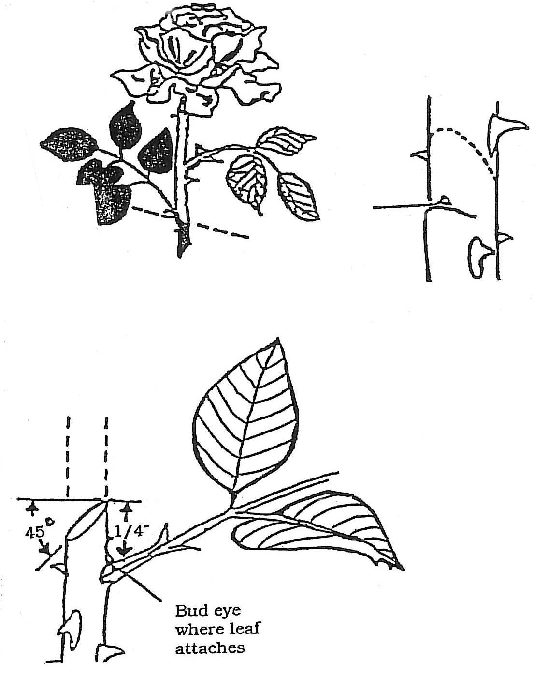
Pruning: In spring, cut back to 9”-12” above ground.
Inspect plant carefully and remove dead or diseased wood, along with any weak and undesirable canes.

For healthy growth, make pruning cut 1” above a live bud at a sharp 35-45 degree angle. Make all cuts ¼” above an outward facing bud or bud eye.

Remove spent blossoms (deadhead) regularly during the growing season to promote more vigorous & continuous bloom. Faded flowers should be removed by pruning just above a five leaflet leaf.

Regular pruning throughout the growing season promotes flower production and a more compact, strong, and bushy plant.

Winter Protection: To minimize the carry over of diseases and pests from season to season, fall/early winter clean-up is essential. Remove any dried leaves from the plant & thoroughly rake and remove any debris. Bag and discard this material. Do not compost.

Shorten canes to a height of 2-1/2 to 3 feet-NO SHORTER. Roses store a great amount of energy in their canes to help them survive the harsh, dry winters of the Rocky Mountain Area. A layer of pine bark mulch 8-9” deep should be applied at the base of each plant towards the end of November, after the ground has frozen. This mulch layer helps prevent damage from heaving and thawing. The use of commercial rose collars will provide even more protection. Rose collars are usually made out of heavy duty plastic, about 8” tall and 10” wide. You snap them together so you have a wall surrounding the rose which is then filled with pine bark mulch. In the spring, remove this or any form of mulching once the danger of frost has past, usually mid-late April.

Winter Watering: Regular winter watering is crucial, particularly during extended dry periods without snow cover. On average, soaking once a month during winter months is recommended-only when the ground is not frozen.

Pests & Diseases: Preventative measures should be taken to minimize problems with pests and disease. Morning watering allows the foliage time to dry out before nightfall, which greatly reduces the incidence of black spot, powdery mildew & rust diseases. Prune throughout the season to remove any canes with black spot or canker. Remove and dispose of all diseased cuttings and canes. Systemic pesticides are absorbed into the plant and cause it to become toxic to insects and reduces the need for spraying. However, spraying may be used for control of aphids, spider mite, white fly, leaf miners, leaf hoppers and other insects.

Please call Echter’s at 303-424-7979 if your rose bush does not seem to be doing well. Perhaps we can diagnose the problem and recommend corrective procedures before the condition worsens.
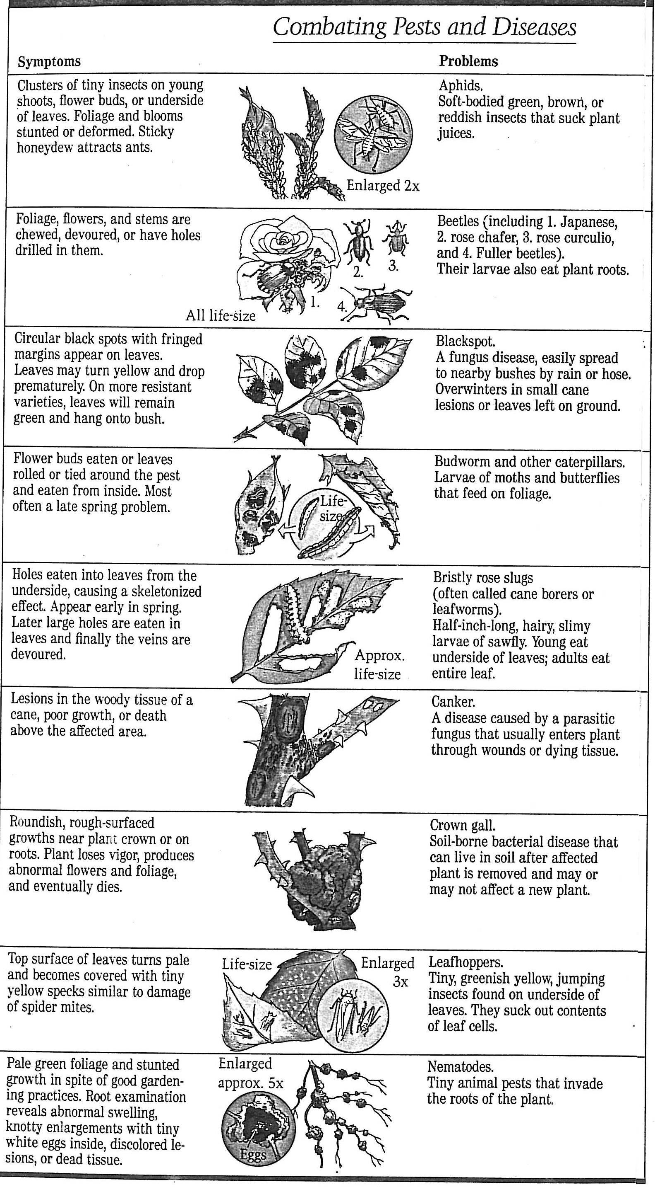

NURSERY, GARDEN CENTER, GREENHOUSE & PATIO
5150 Garrison St. Arvada, CO 80002 303-424-7979
www.echters.com

HOW TO HARDEN OFF YOUR PLANTS

The gradual process of hardening off is a crucial one, like the slow but steady way we brace our entry into a chilly lake in summer. Jumping in all at once is a shock to our system, but if we start by sticking a toe in and slowly working our way in, the total immersion is not nearly so stressful.

Plants need a period of time to get used to their new homes. The adjustment period is called "hardening off." We recommend a hardening off period of about three to five days. This will give the foliage tissue time to toughen up so the plants don't go into shock.

COLD SPRING WEATHER
1. Put new plants outside in a place that is protected from sun and wind. Make sure they get watered as needed.
2. If nights will be cooler than 38-40 degrees, bring into the garage.
3. Move the plants out a little farther each day toward the place in which they will be growing.
4. Leave the plants out at night unless there will be low temperatures. They still might need covering at night if there is a drastic change in the weather.
5. Plant on a cloudy day and they will take right off. Using Fertilome Root Stimulator when planting will help.

WARM SPRING WEATHER

The process above can be sped up, but it is basically the same.

HOT WEATHER
The process here is somewhat different since you are acclimating your plants to hot sun and drying winds.
1. Put plants in a cool, protected place for a day or two.
2. Gradually move plants towards their new location over a period of three or four days.
3. Plant in the cool of the evening or on a cloudy day.
4. Be prepared to shade with a shingle or board until plants are settled in.
5. Water as needed. Always check the soil first.

