
NURSERY, GARDEN CENTER, GREENHOUSE & PATIO
5150 Garrison St. Arvada, CO 80002 303-424-7979
www.echters.com

PAPER WHITE NARCISSUS

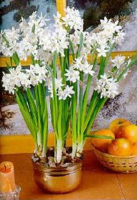
Brighten your winter doldrums with paper white (white) and Soleil d’ Or’ (yellow) narcissus. These bulbs need no pre-cooling or long wait for flowers.

You may plant in soil or in pebbles. The more bulbs in the pot the better display of flowers, but be sure the bulbs do not touch each other.

When you plant in soil you should put soil in the bottom of a pot with drainage, place the bulbs so that they are about in the middle of the pot, then fill the rest of the pot with the soil. Water well to settle the soil and be sure to let the soil go moderately dry between watering so that the bulbs will not rot.

When you plant in pebbles, place the bulbs on one inch of pebbles in a shallow dish or bowl that has no drain hole. Fill in around the bulbs with more pebbles just to the top of the bulbs. Keep water in the bowl just to the bottom of the bulb.

Place the pot in a warm, sunny window – west or east is best. You will see sprouts in just a few days. You will have flowers in six to eight weeks and they will fill your room with a wonderful fragrance.

