

NURSERY, GARDEN CENTER, GREENHOUSE & PATIO
5150 Garrison St. Arvada, CO 80002 303-424-7979
http://www.echters.com/

PEONIES
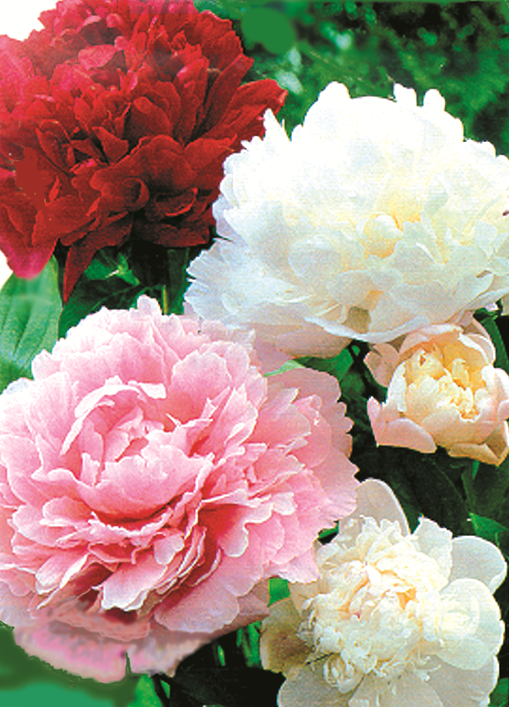
Peonies are hardy and long lived plants. With proper planting and care they become specimen features of the perennial bed or border. Peonies are able to withstand temperatures well below zero and so they are also useful for mountain gardens.

Planting

Once planted, Peonies do not like to be disturbed and may remain in the same place for many years. If possible, plant where they will receive six to eight hours of sun and avoid crowding too closely to other plants. Enrich the soil with sphagnum peat moss and compost. A handful of super phosphate may also be incorporated into the amended planting area. Plant peonies with no more than 1.5" of soil over the bud "eyes". Firm soil carefully and check after watering in that the plant has not settled too deeply. Container plants may be planted anytime from spring through fall. Autumn is the preferable time to lift and relocate peonies to a different position in the garden or to lift those that have failed to flower because they were planted too deeply.

Peonies may be propagated by division in the autumn.. They usually do not need division for many years. To divide lift the roots carefully from the soil with a spading fork. Cut the foliage and stems down to 3"-4". Carefully clean soil from around the crown of the plant. Using a clean knife or other sharp tool, cut the large, fleshy root into divisions with at least 3-5 bud eyes per division.

Watering

Water peonies deeply during dry periods. Because they have such heavy fleshy roots they appreciate thorough watering rather than frequent shallow sprinklings. Watering in April and May is especially important while budding and flowering.

Fertilizing

Feed early each spring with any well balanced fertilizer like Jack’s Classic All-Purpose Fertilizer.

Gardeners sometimes encounter difficulty supporting peony foliage and bloom following rain or wet snow. One method that helps provide added stability to the plant all season is the placement of a 'grow through' grid over the plant early in its spring growth. The peony foliage grows up and through the lateral support grid and is able to 'weather the weather.'

Snip off faded flowers and allow the foliage to accent the garden through the summer. Remember to water thoroughly when necessary. The foliage is manufacturing food all season to insure a bigger more beautiful plant the following year. Foliage should be attractive into the fall usually providing autumn color accent and interest. By November 1-15 it is usually time to cut the stems to a 4"-6" length for the winter.

One final note: The ants that are frequently found on the buds are neither a problem nor necessary to flowers opening. They simply feed on the sweet syrup present on the buds.

TYPES OF PEONIES

SINGLE - five or more petals around a center of stamens and pollen bearing anthers.

JAPANESE - five or more petals around a center of stamens with non-pollen bearing anthers (staminoids).

ANEMONE FLOWERED - the stamens in the center have been transformed into narrow petal-like structures (petaloides).

SEMI-DOUBLE - five or more outer petals around center of broad petals and stamens with pollen
bearing anthers. The stamens are always clearly visible and prominent.

DOUBLE - five or more outer petals but the stamens have been completely transformed into petals and are not a prominent part of the flower.

Reasons Peonies Do Not Bloom:

- Plants too young.
- Planted too deep. Eyes should be no more that 1-2” below soil surface.
- Large clumps planted without first being divided.
- Buds killed by late frost or waterlogged from constant rain.
- Buds killed by disease or attached by thrips. Use an appropriate spray.
- Roots diseased. Destroy plants.
- Plants undernourished. Use a high-phosphate fertilizer like 5-10-5; 6-10-4; 11-5-11.
- Ground too dry. Water thoroughly.
- Excessive hot weather. Late-blooming full doubles are especially susceptible.
- Planted to close to trees and shrubs or crowded by other plants.
- Too much shade, making plants tall and leafy.
- Plants undermined by gophers or moles.

