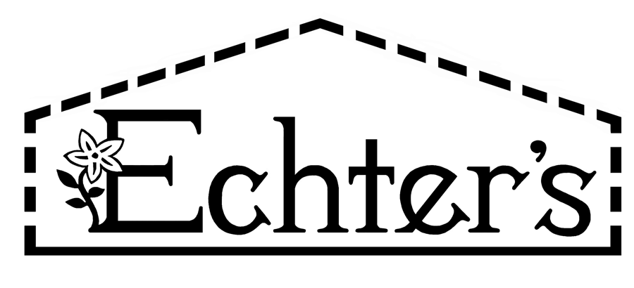

NURSERY, GARDEN CENTER, GREENHOUSE & PATIO
5150 Garrison St. Arvada, CO 80002 303-424-7979

www.echters.com

PERENNIALS FOR SPECIAL LOCATIONS: DRY & SHADY

Dry, shaded areas are often the most difficult to plant. Not only to plants suffer from a lack of sunlight, but moisture is exhausted by neighboring trees and shrubs. To overcome such conditions, add large amounts of compost and begin a regular watering/fertilizing program. These soils are typically not only water deficient but depleted in nutrients.

DRY SHADE
COMMON NAME |  | LATIN NAME |  | BLOOM TIME
Lady's Mantle |  | Alchemilla |  | Summer
Siberian Bugloss |  | Brunnera |  | Summer
Bishop's Cap |  | Epidmedium |  | Spring
Geranium |  | Geranium |  | Summer
Lamium |  | Lamium |  | Spring
Mahonia, Creeping |  | Mahonia repens |  | Spring
Pachysandra |  | Pachysandra |  | Spring
Solomon's Seal |  | Polygonum |  | Spring/Summer
Lungwort |  | Pulmonaria |  | Spring
Lamb's Ear |  | Stachys |  | Summer
Vinca minor |  | Vinca |  | Spring

