# 

**NURSERY, GARDEN CENTER, GREENHOUSE & PATIO**

5150 Garrison St. Arvada, CO 80002 303-424-7979

[www.echters.com](http://www.echters.com) [info@echters.com](mailto:info@echters.com)

#### Planting Roses

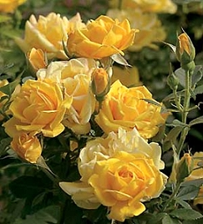

**Recommended products:**

**MYKE Tree and Shrub**

**Nature’s Yield Compost**

**Mulch**

**Fertilome Rose Food**

1. Determine the location. Roses prefer a sunny, well-drained spot receiving at least 6 hours of sun per day with good air circulation. The area should be located away from competition from other trees and shrubs.
2. During hot weather, plant in the cool of the morning or evening or on a cloudy day to minimize transplant shock.
3. If the root ball is dry, water and let excess water drain prior to planting.
4. Dig a hole 3x as wide as the pot and the same depth as the soil in the pot.
   1. ***If the rose is grafted, dig the hole deep enough so that the graft union will be just below the ground level.***
5. Thoroughly mix together 1 part compost to 2 parts of the soil that has been removed from the hole.
6. Lay the pot on its side. Use gloves to protect your hands from the thorns. Hold canes firmly and carefully slide pot away from root ball. Rub MYKE Tree and Shrub directly onto all parts of the root ball and place into planting hole. Backfill with the compost-soil mixture, firming lightly as you go.
7. Water thoroughly around the **base** of the plant. Avoid overhead watering practices, as roses do not like wet leaves. Mulching the surrounding area will help conserve moisture in the soil & reduce weed growth.
8. Water when the soil is dry to the touch about 1” below the surface along the outside edge of the original root ball. Wait 4 weeks to start fertilizer applications.

##### Rose Care & Culture

**Watering:** Normally, roses should receive 1” of water per week, slightly more during hot, dry periods. Apply water during the morning hours around the base of the plant. Evening watering and overhead watering create conditions conducive to rose diseases.

**Fertilizing:** Start fertilizing in the spring when plant has put on several inches of new growth. Follow the directions on your fertilizer. We recommend Ferti-lome Rose Food or Ferti-lome Rose Food with Systemic Insecticide. Dry fertilizers are worked into the soil and watered in. Water- soluble fertilizers are mixed with water and then applied. Don’t fertilize after August 1. This allows the plant to slow down and harden off so it will better survive the winter.

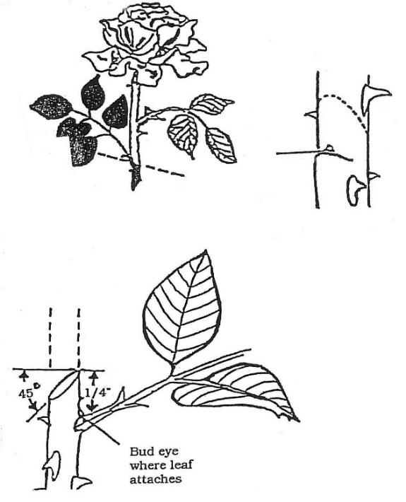

**Pruning:** Regular pruning promotes flower production and a more compact, strong, and bushy plant. Use rose gloves to protect your hands and forearms when pruning.

In the spring, cut back stems to 9”-12” above ground.

Inspect plant carefully and remove dead or diseased wood, along with any weak or undesirable canes. Prune to give the bush an arching shape. For healthy growth, make pruning cuts with a sharp bypass pruner at a 45 degree angle to the stem. Try to prune at 1” or less above an outward facing bud.

Remove spent blossoms regularly during the growing season to promote more vigorous & continuous bloom. Faded flowers should be removed by pruning to just above a five leaflet leaf.

**Winter Protection:** To minimize the carryover of diseases and pests from season to season, remove any dried leaves from the plant & thoroughly rake and remove any debris in November. Bag and discard this material. Do not compost. Plastic rose collars filled with Mini Nuggets 8” deep should be applied around the base of each plant towards the end of November. This mulch layer helps prevent damage from temperature extremes and from ground heaving and thawing. In mid-April remove the collars and Mini Nuggets once the danger of freezing temperatures has passed.

**Winter Watering** is crucial, particularly during extended dry periods without snow cover. On average, soak once a month during the winter months if the ground is not frozen.

**Pests & Diseases:** Preventative measures should be taken to minimize problems with pests and disease. Keeping the foliage dry greatly reduces the incidence of diseases. Remove and dispose of all diseased cuttings and canes. Systemic pesticides are absorbed into the plant and cause it to become toxic to insect pests. Spraying may also be used to control insects.

Please e-mail a picture to [info@echters.com](mailto:info@echters.com) or call us at 303-424-7979 if your rose bush does not seem to be doing well. Perhaps we can diagnose the problem and recommend corrective procedures before the condition worsens.