

NURSERY, GARDEN CENTER, GREENHOUSE & PATIO
5150 Garrison St. Arvada, CO 80002 303-424-7979
www.echters.com

Planting Strawberries

Plant strawberries with roots spread in fan shape.
Barely cover the crown.



Two ways of spacing runners
in a malled row system.

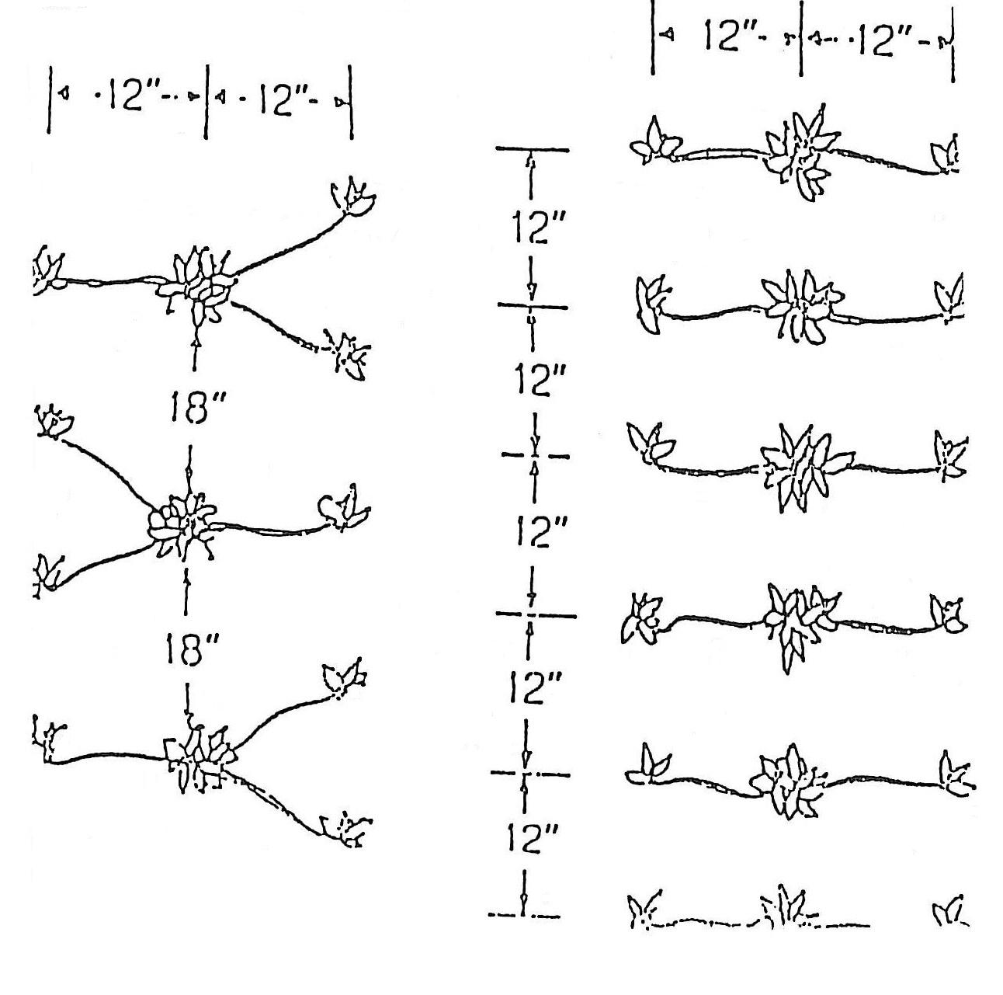

Double row system
